**Instituto Privado Mixto**

**“Rafael Arévalo Martínez”**

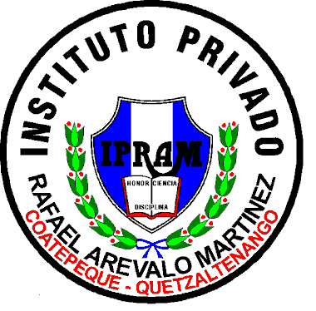

**Nombre del Estudiante: Thelma Merari**

**Vásquez López**

**Catedrático: Maríliz Ramos**

**Grado: Segundo Básico**

**Curso: Inglés**

**Trabajo: Actividad #4 IV Bloque**

**Ciclo Escolar: 2,021**

Have you ever cut your hair?

Yes, I cut it a couple of months ago.

Have you ever tried blue cheese?

No, the truth is that I have never seen and tasted it

Have you ever tried Korean food?

No, the truth is, if I would like to try it

Have you ever lost your ID?

No