Alumnos : Dayana Rogel

Samantha Franco

Mario Arévalo

Jonathan Aguilar

Eunice Estrada

Sofia Marroquin

Grado : 5to BACO

Clase : laboratorio

Tema : FACEBOOK

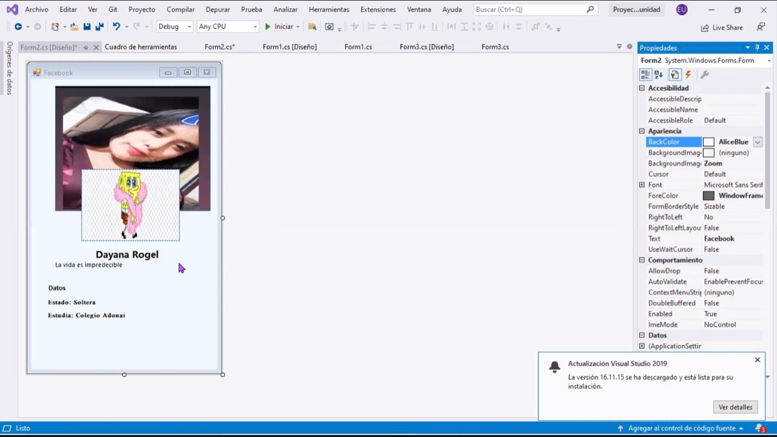

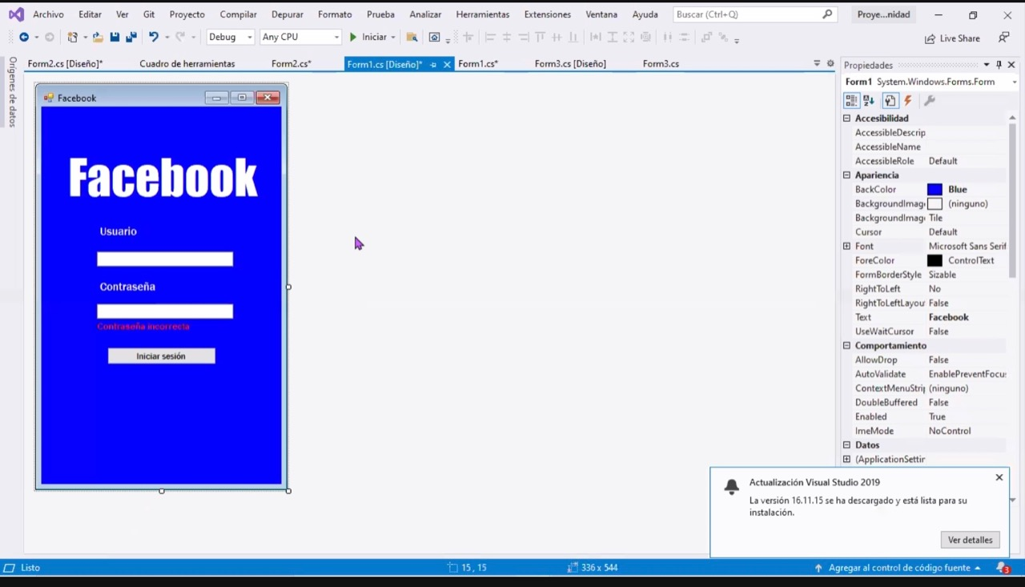

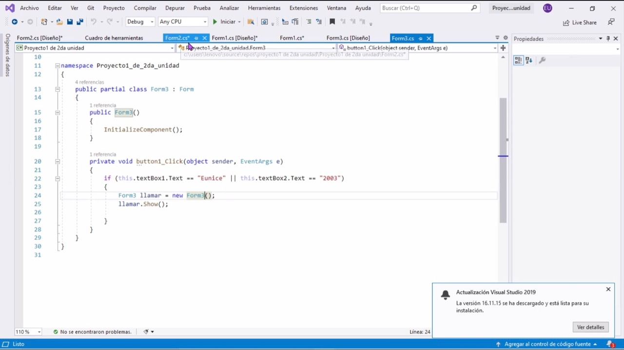

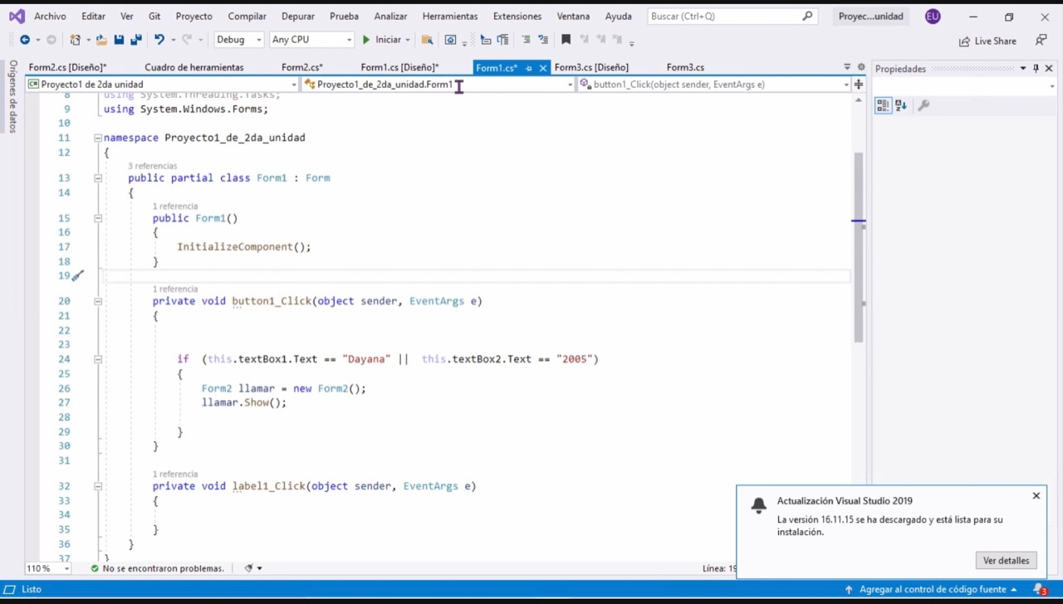

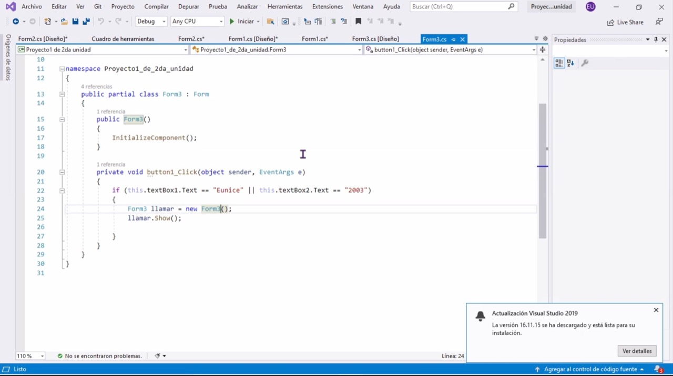

{  
foreach ( Control c in Controls)  
{  
Button x = (Button)c;  
x.Enabled = false;  
x.Text = "";  
}  
  
}  
catch { }  
}  
  
  
private void salirToolStripMenuItem_Click(object sender, EventArgs e )  
{  
this.Close();  
}  
  
  
}  
}  
  
namespace Proyecto1_de_2da_unidad  
{  
public partial class Form1 : Form  
{  
public Form1()  
{  
InitializeComponent();  
}  
  
private void button1_Click(object sender, EventArgs e)  
{  
  
  
if (this.textBox1.Text == "Dayana" || this.textBox2.Text == "2005")  
{  
Form2 llamar = new Form2();  
llamar.Show();  
  
}  
}  
  
private void label1_Click(object sender, EventArgs e)  
{  
  
}  
}  
}  
  
public partial class Form3 : Form  
{  
public Form3()  
{  
InitializeComponent();  
}  
  
private void button1_Click(object sender, EventArgs e)  
{  
if (this.textBox1.Text == "Eunice" || this.textBox2.Text == "2003")  
{  
Form3 llamar = new Form3();  
llamar.Show();  
  
}  
}  
}