**Instituto Privado Mixto**

**“Rafael Arévalo Martínez”**

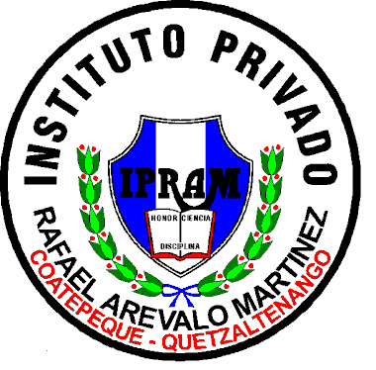

**Alumna: Maylin Guadalupe Vásquez López**

**Catedrática: Mariliz Ramos**

**Grado: Segundo Básico**

**Sección: “A”**

**Ciclo Escolar: 2,021**

1. Did you go to the party yesterday?

Yes

1. What did you do yesterday afternoon?

I went to eat

1. Did you go to the market in the morning?

Yes

1. Where did you go on Friday night?

I went to a party

1. What did you eat yesterday?

I ate meat cakes

1. Did you go shopping on Sunday?

Yes, in the afternoon

1. What did you do on Saturday?

I went to visit my aunts

1. What did you do on the weekend?

I went for a walk with my friends

1. Where did you go to eat yesterday?

We went to McDonald's

1. Where did you buy your clothes yesterday?

In the usual boutique