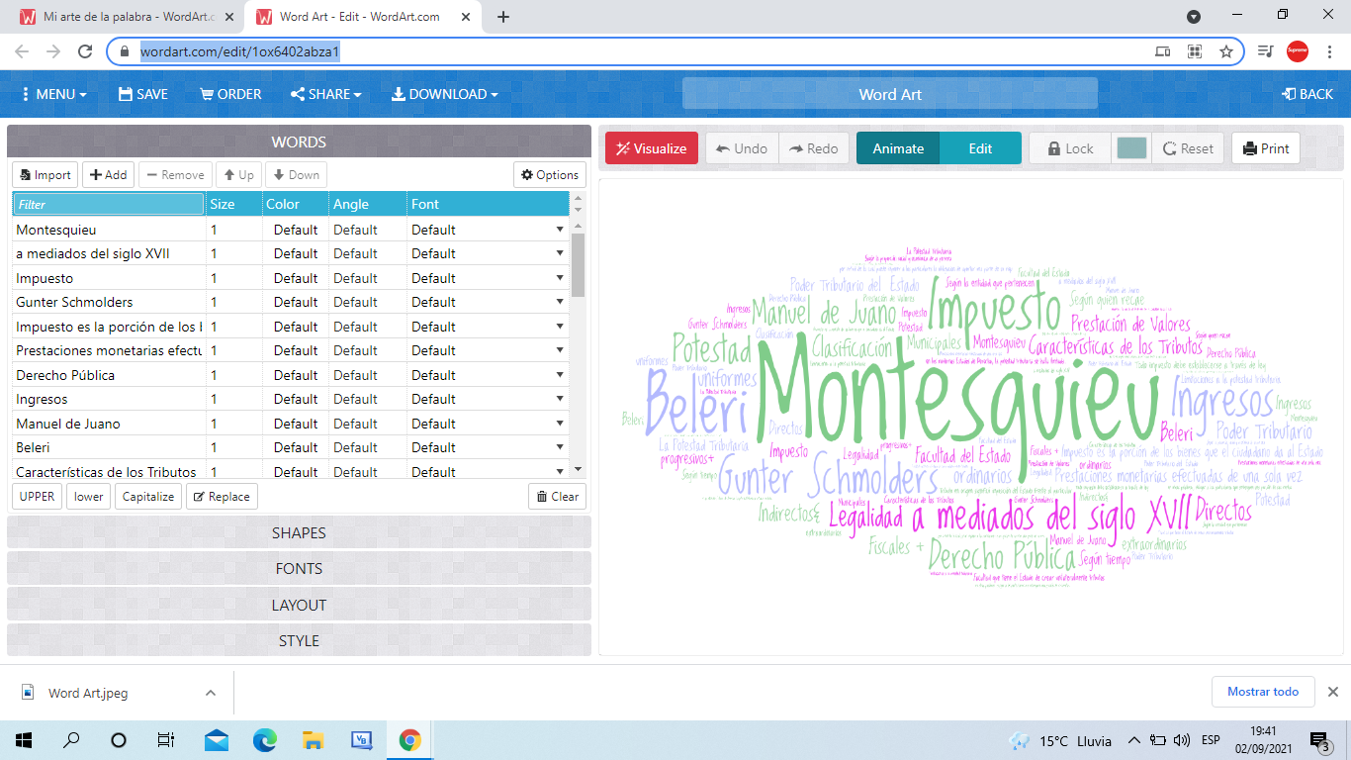

https://wordart.com/edit/1ox6402abza1