Coatepeque Thursday, may 6, 2021

Name: Mariann Daniela Cifuentes Ovalle

Grade: First Basic

Course: Communication and Language Foreign Language

Teacher: Mariliz Ramoz

Institute: Rafael Arévalo Martínez Prívate Institute

Activity 2 second block

Lesson 1 week 10

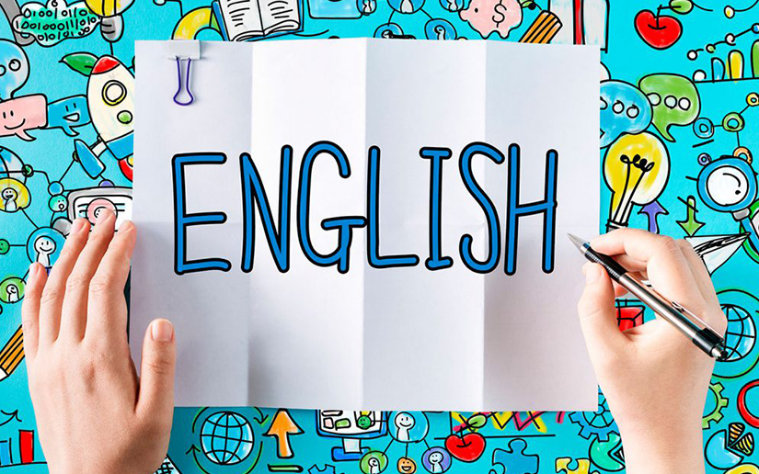

Instructions: complete the sentences. Then tell a partner about yourself. / complete las oraciones. Entonces comente a su compañero de usted mismo.

1. My name is Mariko Kimura i am from Japan my family is in Osaka.

Our brother is a unversity student its name is Kenji.

1. My name is Antonio i am from Buenos Aires its areally nice city my sister is a student here, too my parents are in Argentina right now.
2. I am Katherine, but averyone calls me katie. my last name is Martin. I am a student at city college. My parents are on vacation this week until in Los Angeles.