**COLEGIO CIENTIFICO MONTESSORI, SOLOLA BACHILLERATO EN CIENCIAS Y LETRAS CON ORIENTACIÓN EN COMPUTACIÓN ESTADISTICA DESCRIPTIVA MEDIDAS DE TENDENCIA CENTRAL Y DE DISPERSION PARA DATOS AGRUPADO**

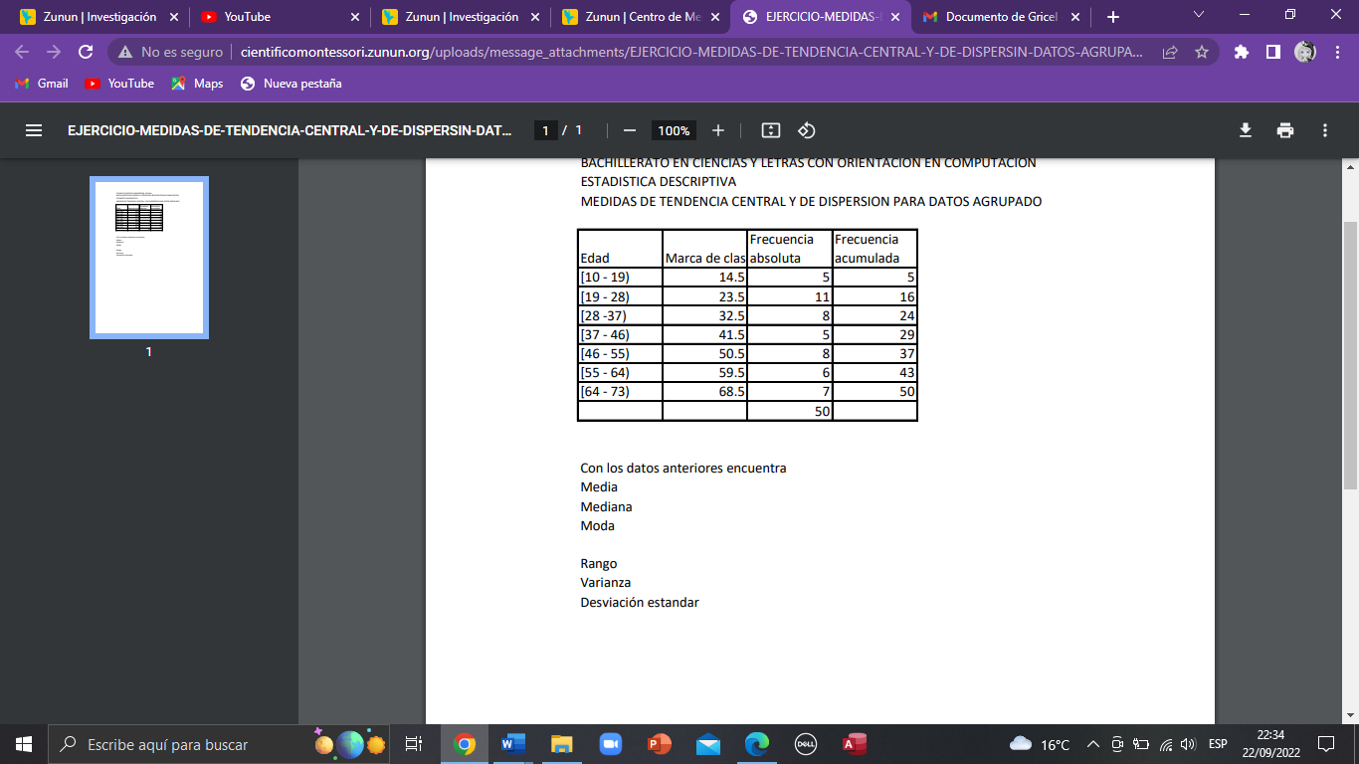

Media:

|  |  |  |  |  |
| --- | --- | --- | --- | --- |
| Intervalos | Intervalos | Marca de clase  Xi | Frecuencia absoluta fi | Frecuencia acumulada  Fi |
| Inf | Sup |  |  |  |
| 10 | 19 | 14,5 | 5 | 5 |
| 19 | 28 | 23,5 | 11 | 16 |
| 28 | 37 | 32,5 | 8 | 24 |
| 37 | 46 | 41,5 | 5 | 29 |
| 46 | 55 | 50,5 | 8 | 37 |
| 55 | 64 | 59,5 | 6 | 43 |
| 64 | 73 | 68,5 | 7 | 50 |

50

|  |  |
| --- | --- |
| xi *fi | Total, de xi*fi 209 |
| 72,5 |  |
| 258,5 |  |
| 260 |  |
| 207,5 |  |
| 404 |  |
| 357 |  |
| 479,5 |  |

|  |
| --- |
| Total, de (xi*fi) / Total de fi (50) =40, 78 |

|  |
| --- |
| Media 40,78 |

Mediana

|  |  |  |  |  |
| --- | --- | --- | --- | --- |
| Intervalos | | Marca de clase  Xi | Frecuencia absoluta fi | Frecuencia acumulada Fi |
| Inf | Sup |  |  |  |
| 10 | 19 | 14,5 | 5 | 5 |
| 19 | 28 | 23,5 | 11 | 16 |
| 28 | 37 | 32,5 | 8 | 24 |
| 37 | 46 | 41,5 | 5 | 29 |
| 46 | 55 | 50,5 | 8 | 37 |
| 55 | 64 | 59,5 | 6 | 43 |
| 64 | 73 | 68,5 | 7 | 50 |

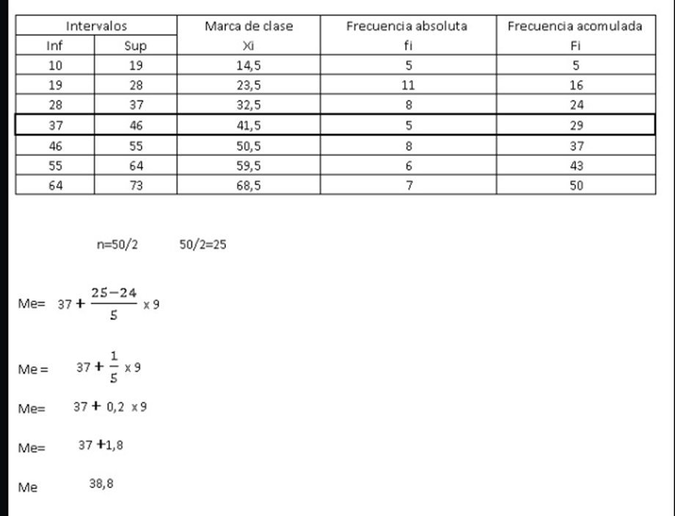

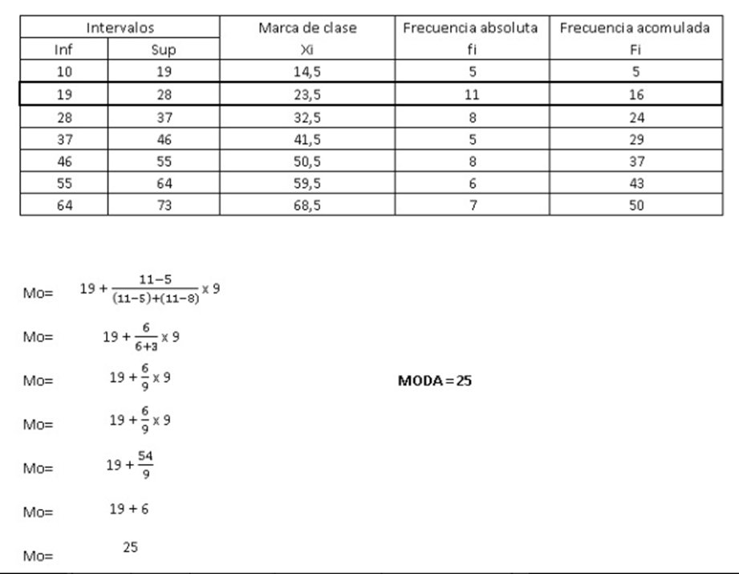

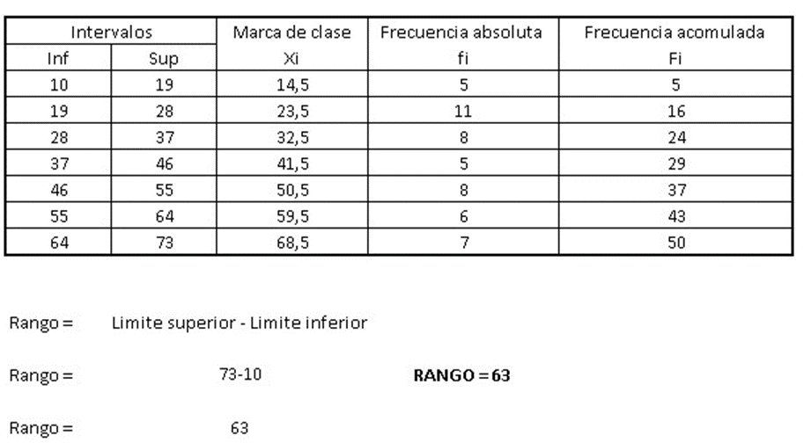

**Varianza**

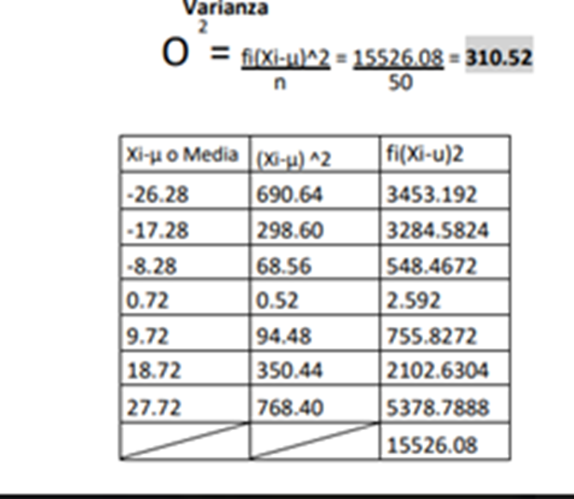

= 310. 52

|  |  |  |
| --- | --- | --- |
| Xi u o media | (Xiu)^2 | Fi (Xi-u)2 |
| -26.28 | 690.64 | 3453.192 |
| -17.28 | 298.60 | 3284.5824 |
| -8.28 | 68.56 | 548.4672 |
| 0.72 | 0.52 | 2.592 |
| 9.72 | 94.48 | 755.8272 |
| 18.72 | 350.44 | 2102.6304 |
| 27.72 | 768.40 | 5378.7888 |
| / | / | 15526.08 |

**Desviación estándar**

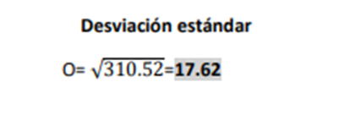

= 17.62