1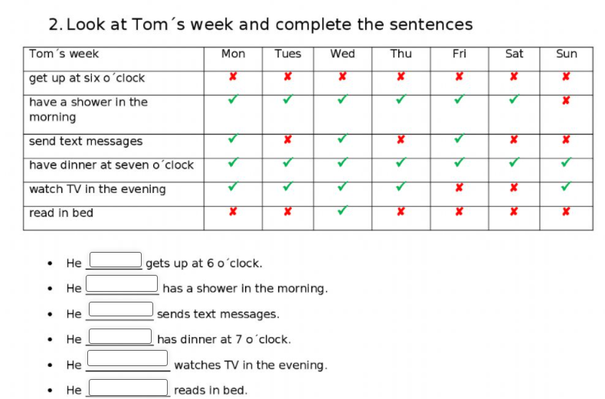

Respuestas:

1. Never

2. Usually

3. Sometimes

4. Always

5. Often

6. Hardly never