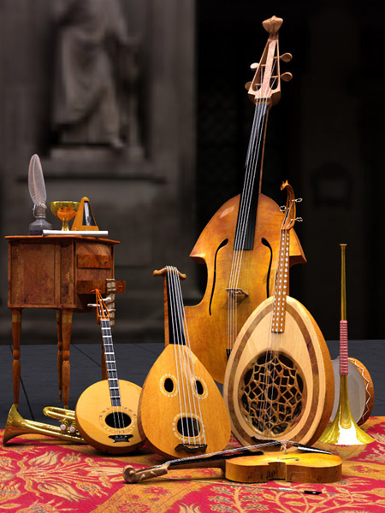
Nombre: Wendy Marisol Herrera Gomez.

Grado: 5to bachillerato.

Colegio: colegio del futuro.

Catedrática: Sandra Elizabeth Pajarito Chamalé.

Curso: Expresión Artística.

Semana: 25.

Trabajo: canciones.

Fecha: 15-07-2020.
Investiga sobre estas canciones, escribe a qué película corresponden y coloca le letra de la que más te guste y explica por qué:
- Eye of the tiger: Rocky.
- Ghostbusters: Los caza fantasma.
- The Power of Love: Regreso al futuro.
- Singing In The Rain: Cantando bajo la lluvia.
- Over the Rainbow: Mago de oz.
- My Heart Will Go On: Titanic.
- Will Always Love You: The best Little whorehouse in Texas.
- Hakuna Matata: el rey león.
Risin' up, back on the street
Did my time, took my chances
Went the distance, now I'm back on my feet
Just a man and his will to survive
So many times, it happens too fast
You trade your passion for glory
Don't lose your grip on the dreams of the past
You must fight just to keep them alive
It's the eye of the tiger, it's the thrill of the fight
Risin' up to the challenge of our rival
And the last known survivor stalks his prey in the night
And he's watchin' us all with the eye of the tiger
Face to face, out in the heat
Hangin' tough, stayin' hungry
They stack the odds 'til we take to the street
For the kill with the skill to survive
It's the eye of the tiger, it's the thrill of the fight
Risin' up to the challenge of our rival
And the last known survivor stalks his prey in the night
And he's watchin' us all with the eye of the tiger
Risin' up, straight to the top
Had the guts, got the glory
Went the distance, now I'm not gonna stop
Just a man and his will to survive
It's the eye of the tiger, it's the thrill of the fight
Risin' up to the challenge of our rival
And the last known survivor stalks his prey in the night
And he's watchin' us all with the eye of the tiger
The eye of the tiger
The eye of the tiger
The eye of the tiger
The eye of the tiger.

Esta es la canción me gusta porque, aunque es antigua es muy moderna y original.
(eye of the tiger).

