COLEGIO CIENTIFICO MONTESSORI, SOLOLA

BACHILLERATO EN CIENCIAS Y LETRAS CON ORIENTACIÓN EN COMPUTACIÓN ESTADISTICA DESCRIPTIVA

MEDIDAS DE TENDENCIA CENTRAL PARA DATOS AGRUPADOS

|  |  |  |  |  |  |  |
| --- | --- | --- | --- | --- | --- | --- |
| clases |  | Marca de clase | frecuencia | F. Acumulada | f. relativa | F. R. Acumulada |
| lim. Inferiror | lim. Superiror | Ci | fi | Fi | ni | Ni |
| [15 | 20) | 17.5 | 4 | 4 | 0.055 | 0.055 |
| [20 | 25) | 22.5 | 7 | 11 | 0.096 | 0.151 |
| [25 | 30) | 27.5 | 9 | 20 | 0.123 | 0.274 |
| [30 | 35) | 32.5 | 15 | 35 | 0.205 | 0.479 |
| [35 | 40) | 37.5 | 18 | 53 | 0.247 | 0.726 |
| [40 | 45) | 42.5 | 8 | 61 | 0.110 | 0.836 |
| [45 | 50) | 47.5 | 6 | 67 | 0.082 | 0.918 |
| [50 | 55) | 52.5 | 3 | 70 | 0.041 | 0.959 |
| [55 | 60) | 57.5 | 2 | 72 | 0.027 | 0.986 |
| [60 | 65) | 62.5 | 1 | 73 | 0.014 | 1.000 |
|  |  |  | 73 |  | 1.000 |  |

|  |  |  |
| --- | --- | --- |
| Marca de Clase | Fi | Marca de clase frecuencia total |
| 17.5 | 4 | 70 |
| 22.5 | 7 | 157.5 |
| 27.5 | 9 | 247.5 |
| 32.5 | 15 | 487.5 |
| 37.5 | 18 | 675 |
| 42.5 | 8 | 340 |
| 47.5 | 6 | 285 |
| 52.5 | 3 | 157.5 |
| 57.5 | 2 | 115.5 |
| 62.5 | 1 | 62.5 |
|  |  | 2597.5 |
|  |

Encuentra:

Media: 35.582 Formula:

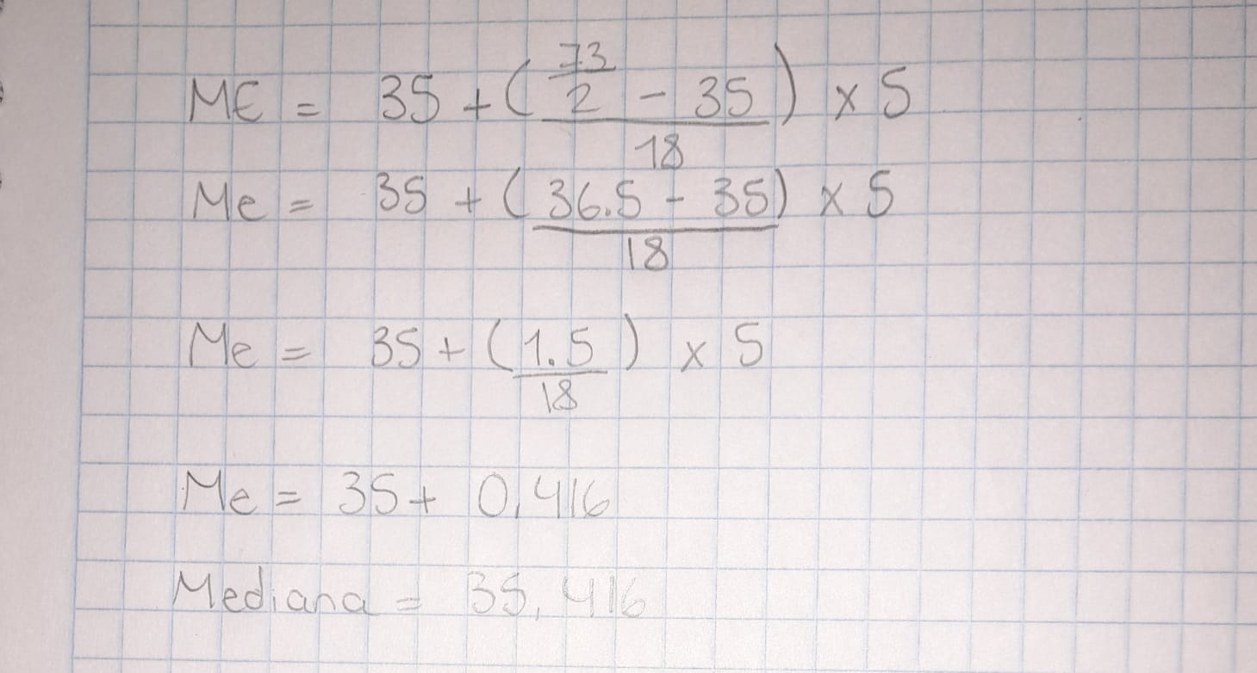Mediana: 35.416

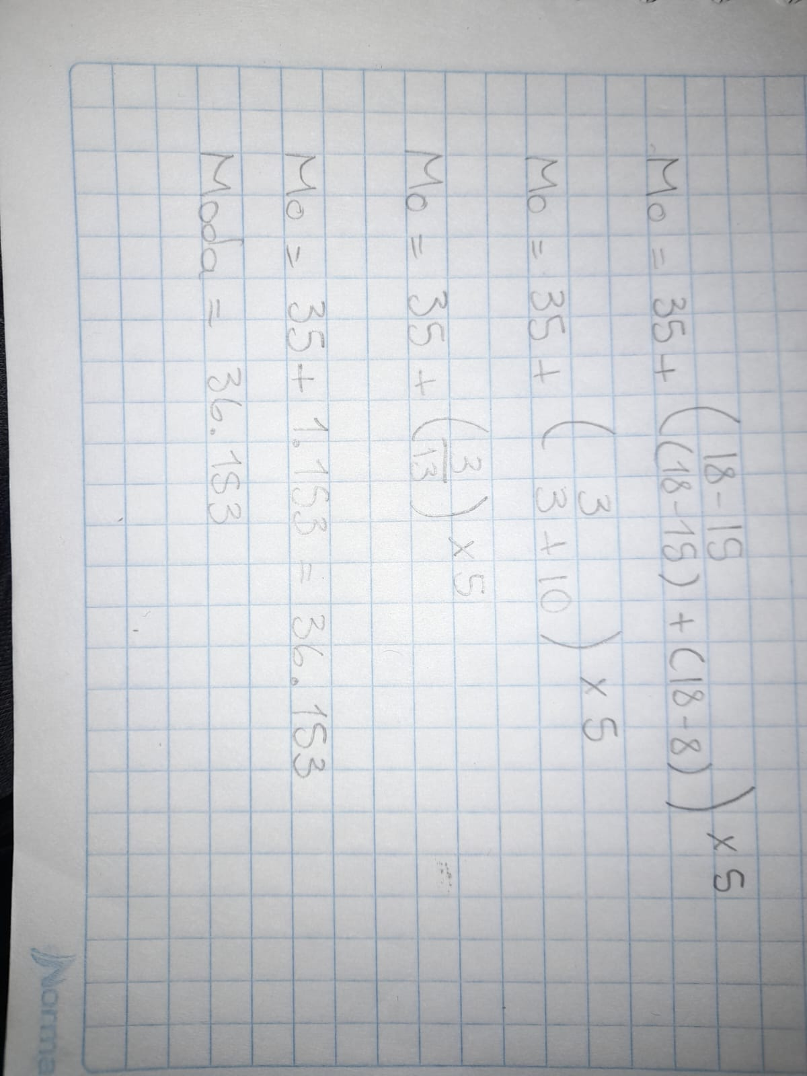

Moda: 36.153}