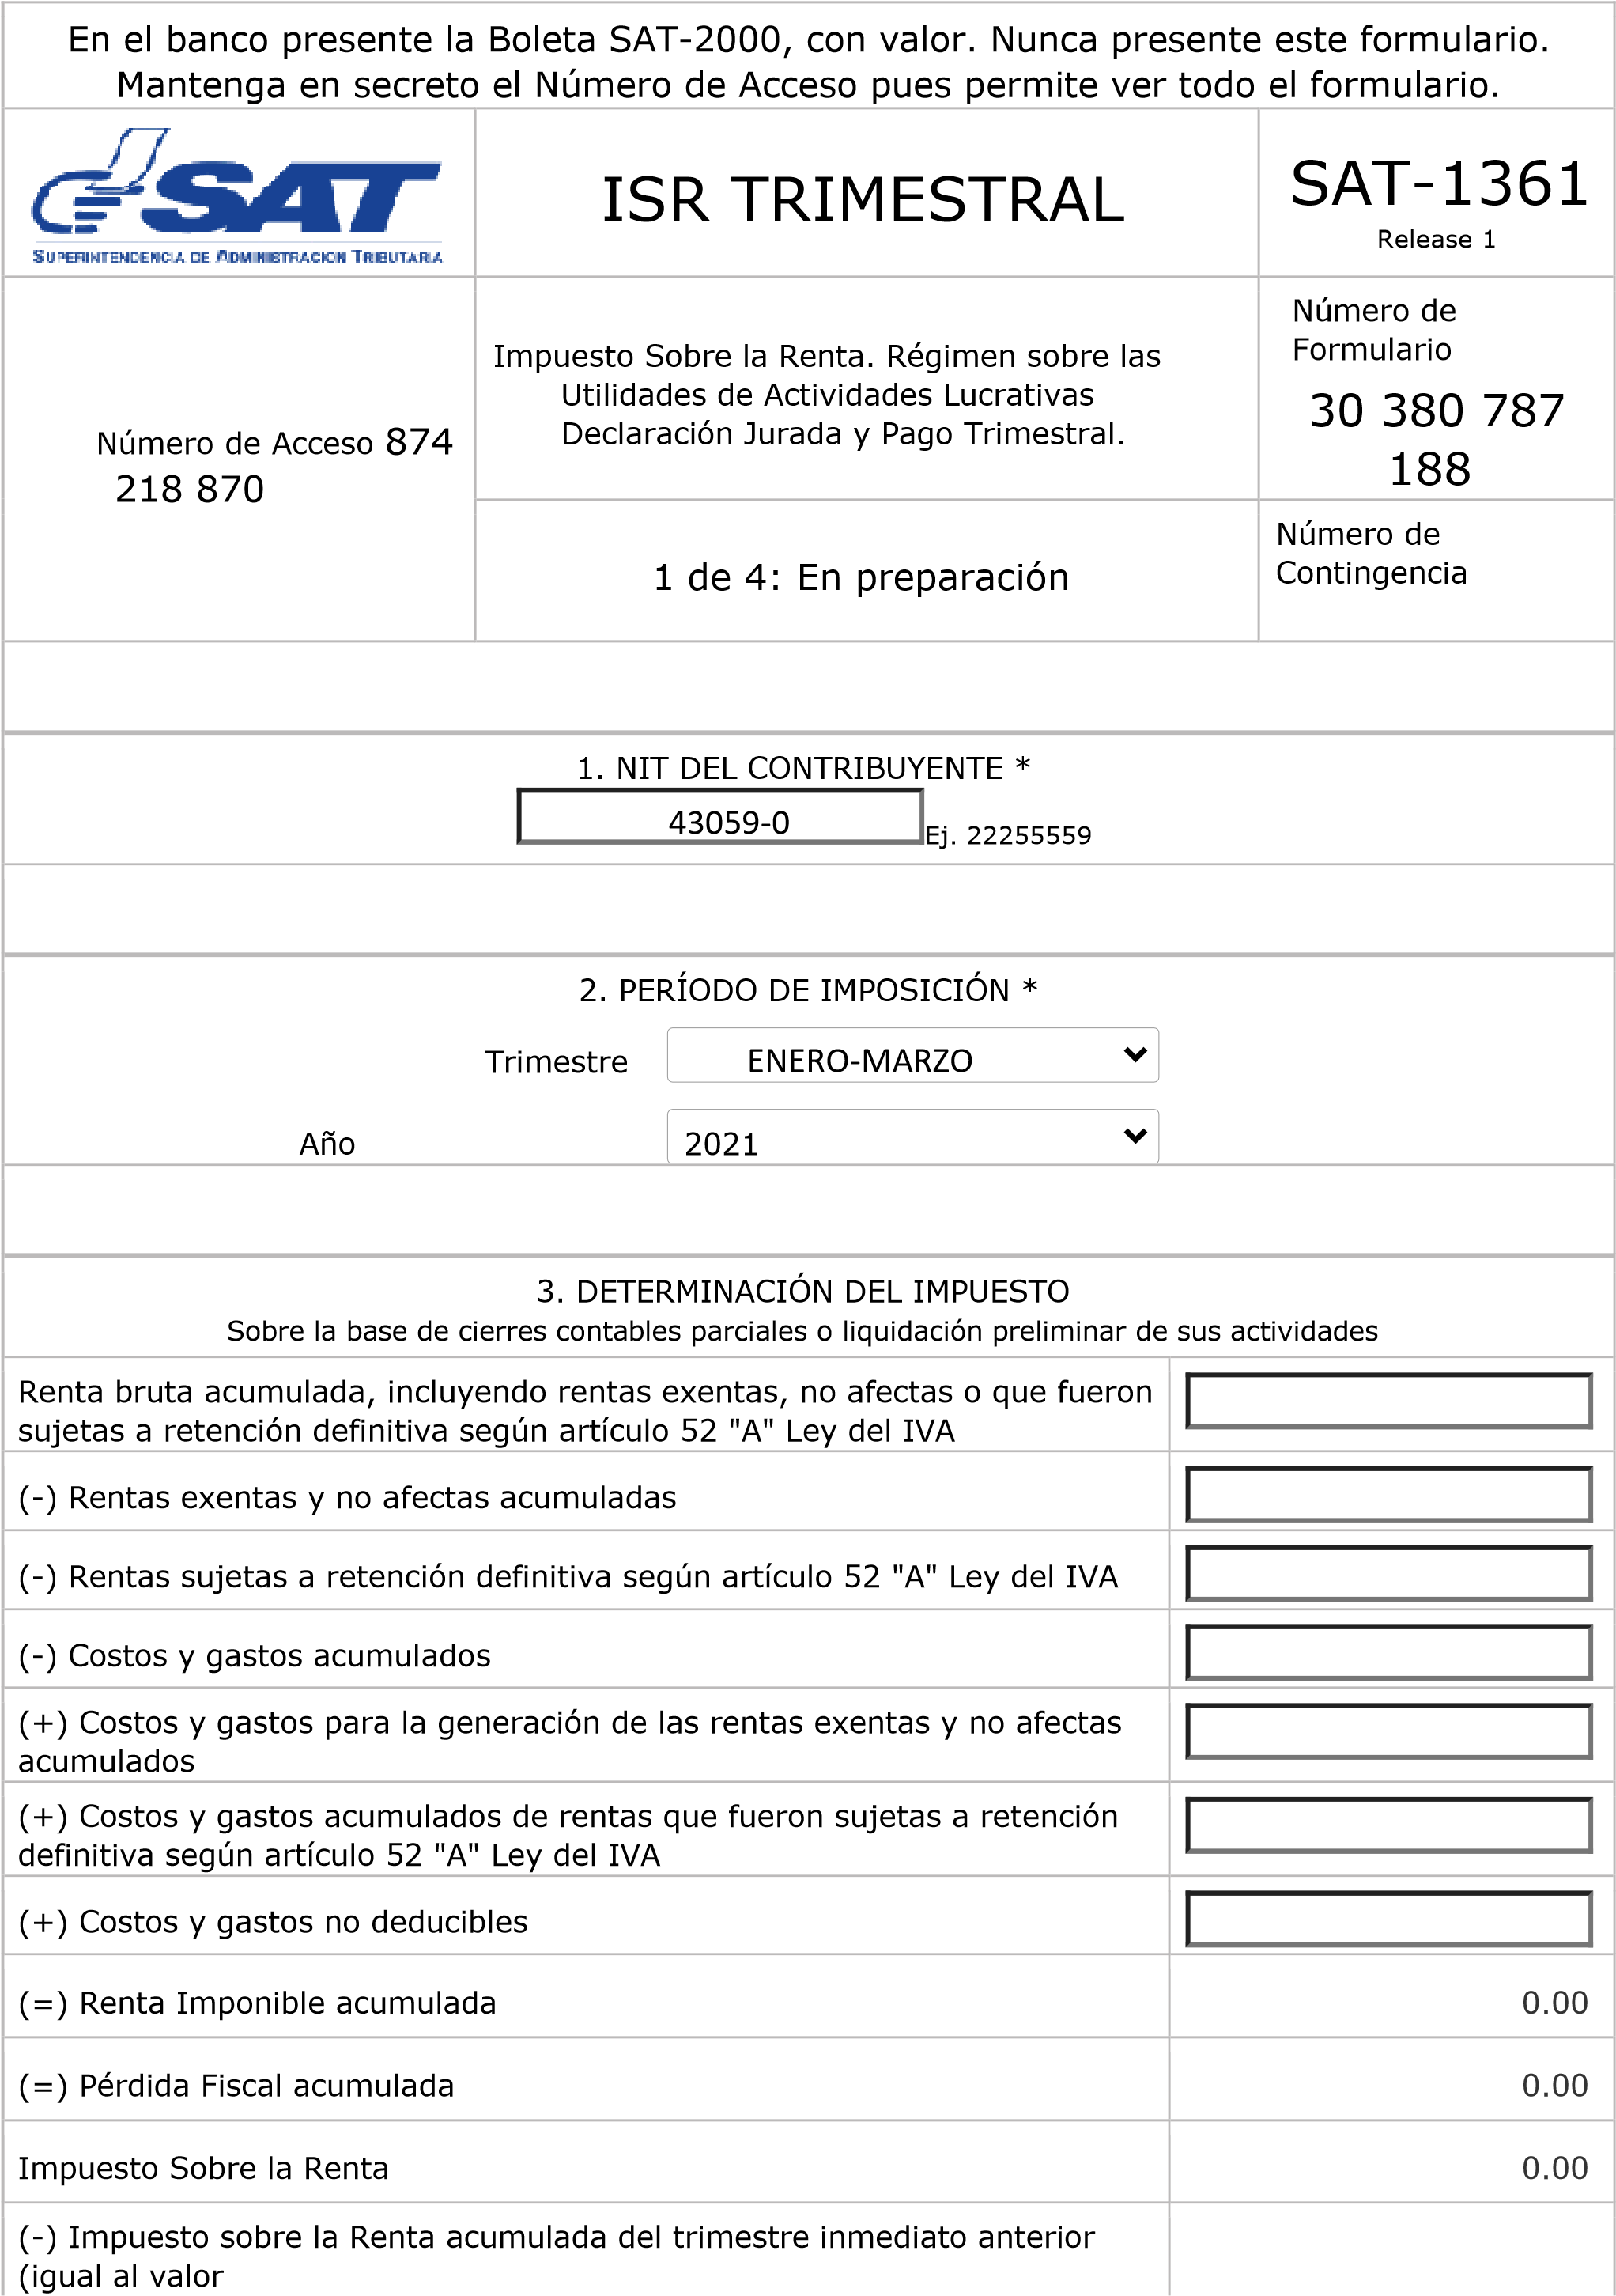

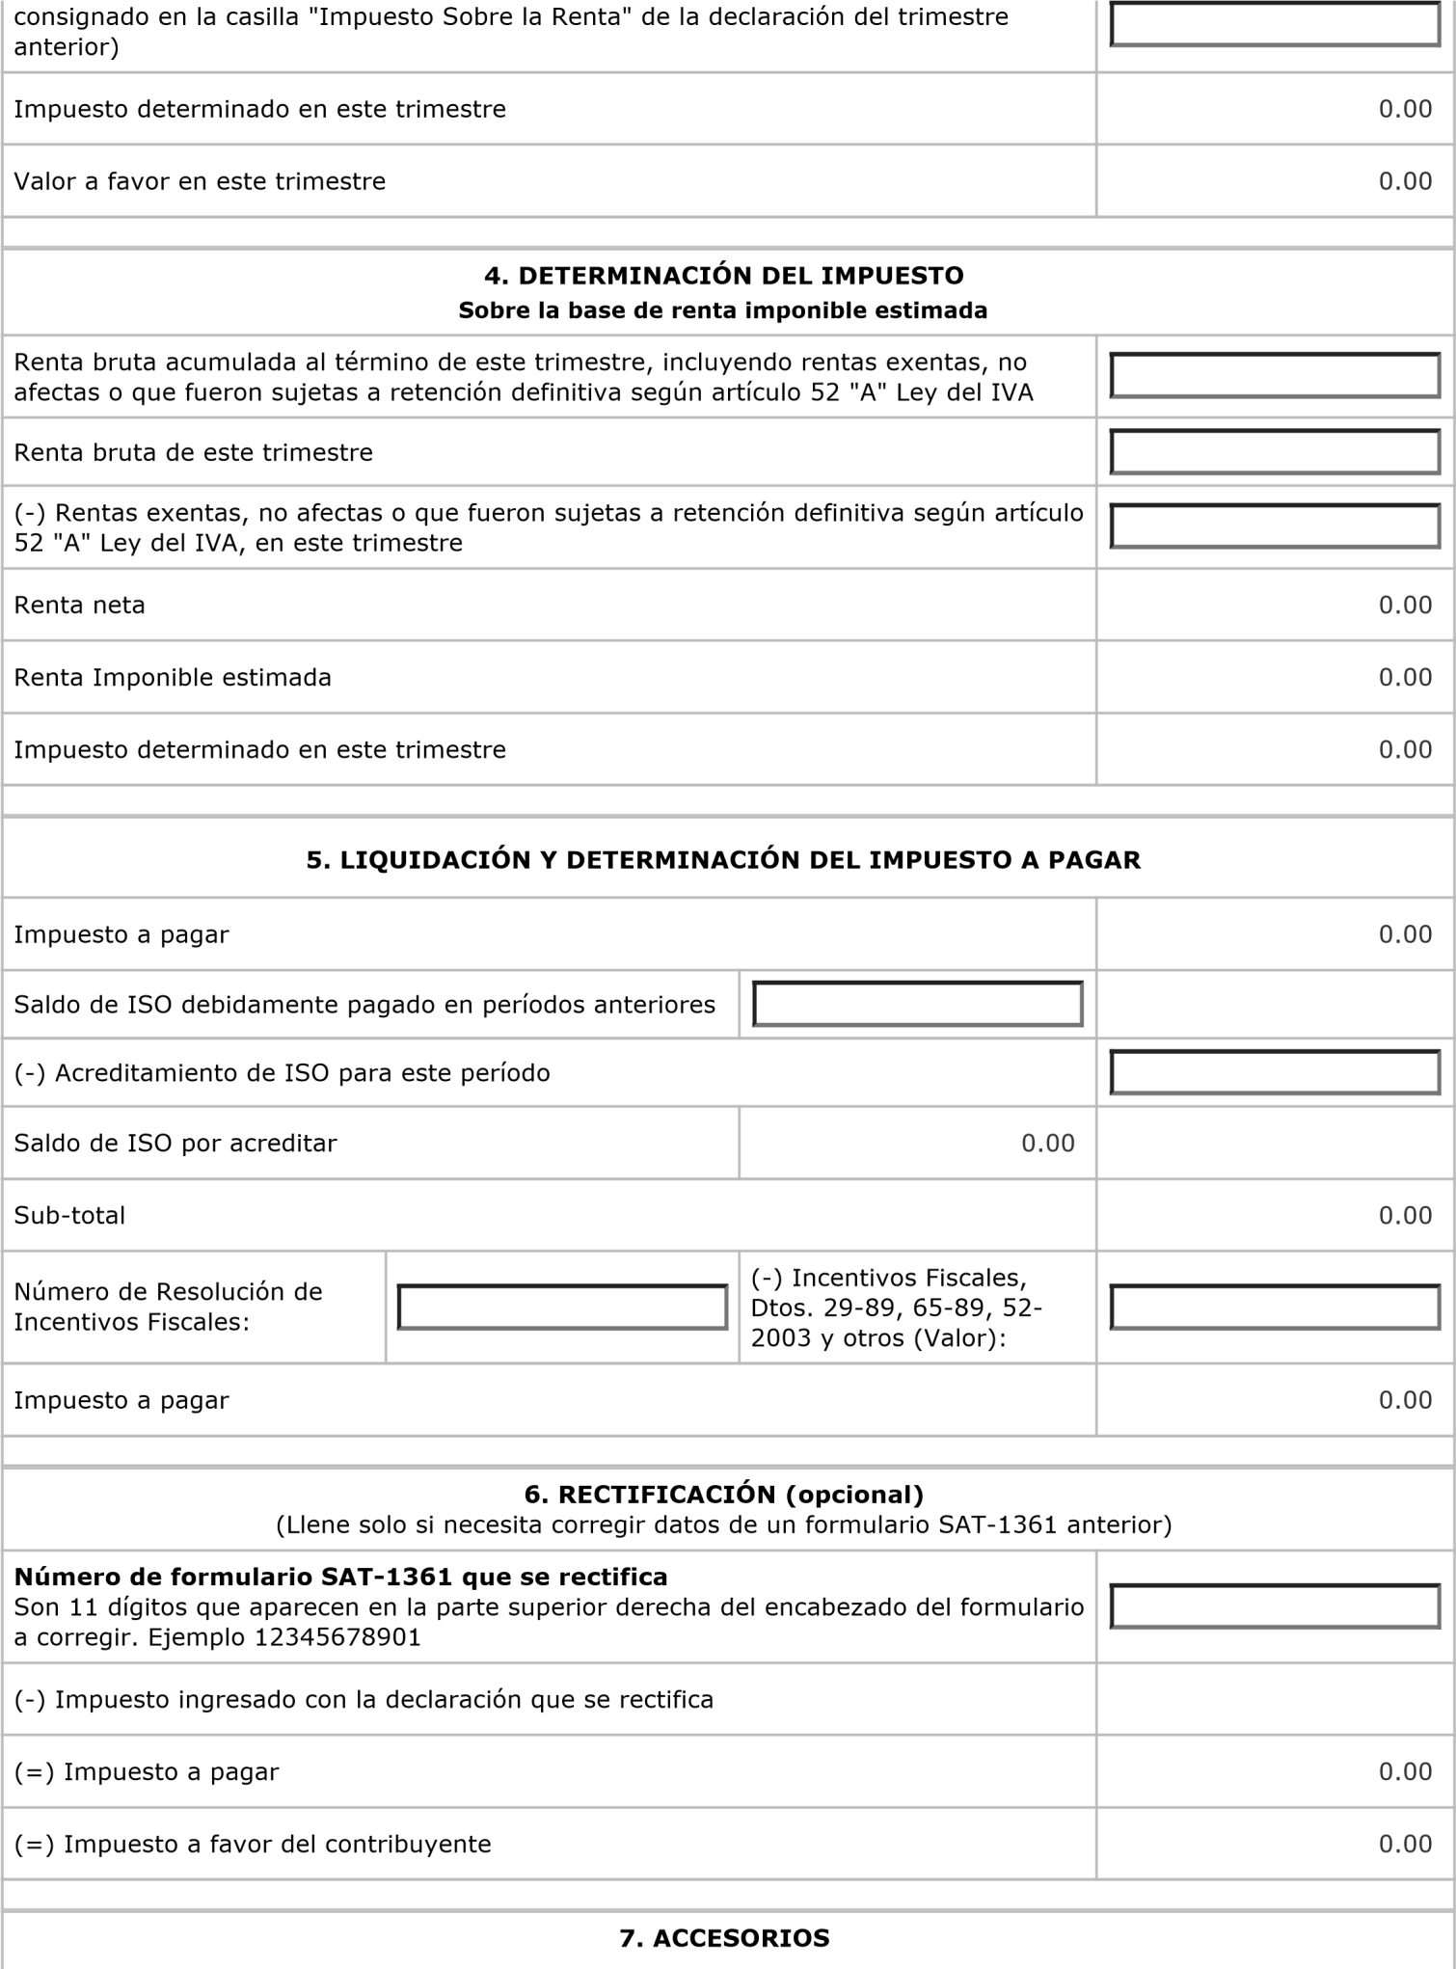

Q.150,000.00

Q.130,000

Q.150,000.00

Q.12,000.00

Q.3,000.00

Q.3,000

Q.3,000

Q.3,000

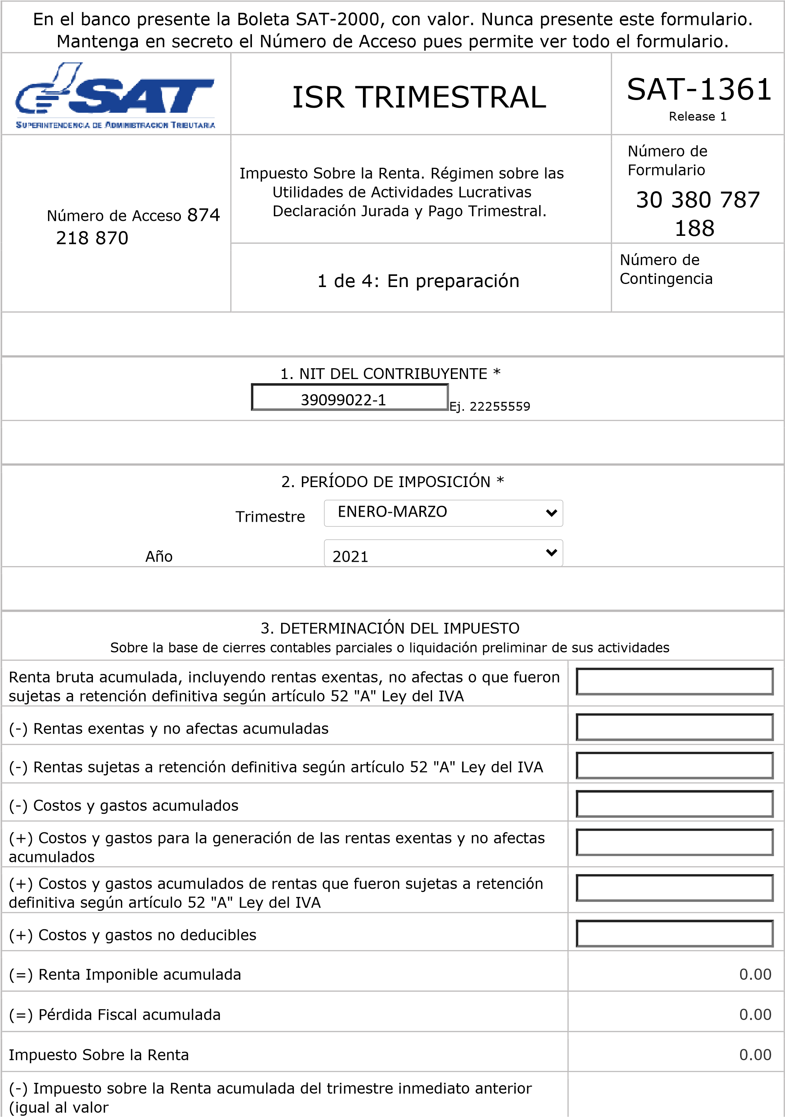



Q.850,000.00

Q.880,000.00

Q.88

0,000.00

Q.

70,400.00

Q.17,600.00

Q.17,600.00

Q.17,600.00

Q.17,600.00

