|  |  |  |  |  |
| --- | --- | --- | --- | --- |
|  |  |  |  |  |
|  |  | marca de clase | fi | marca de clase*frecuencia total |
| medida: 35.582 formula | | 17.5 | 4 | 70 |
|  |  | 22.5 | 7 | 157.5 |
|  |  | 27.5 | 9 | 247.5 |
|  |  | 32.5 | 15 | 487.5 |
|  |  | 37.5 | 18 | 675 |
|  |  | 42.5 | 8 | 340 |
|  |  | 47.5 | 6 | 285 |
|  |  | 52.5 | 3 | 157.5 |
|  |  | 57.5 | 2 | 115.5 |
|  |  | 62.5 | 1 | 62.5 |
|  |  |  |  | 2597.5 |

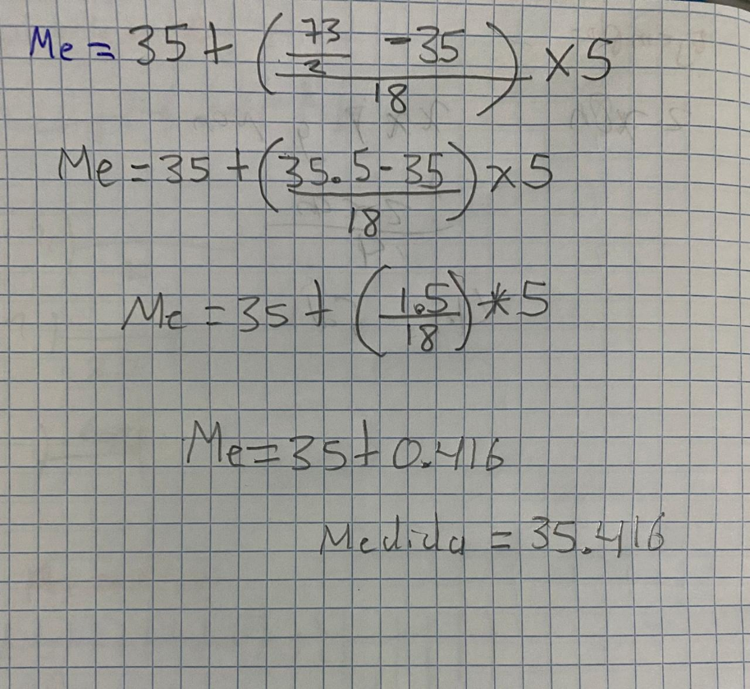

**Mediana: 35.416**

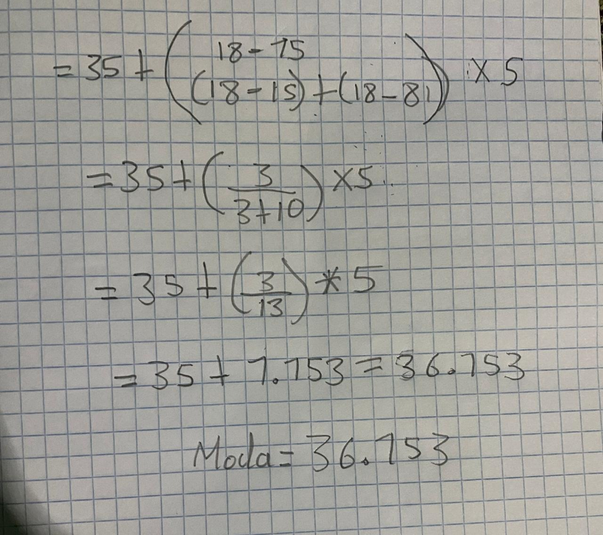

**Moda: 36.153**