**COLEGIO CIENTIFICO MONTESSORI, SOLOLA**

**BACHILLERATO EN CIENCIAS Y LETRAS CON ORIENTACIÓN EN COMPUTACIÓN**

**ESTADISTICA DESCRIPTIVA**

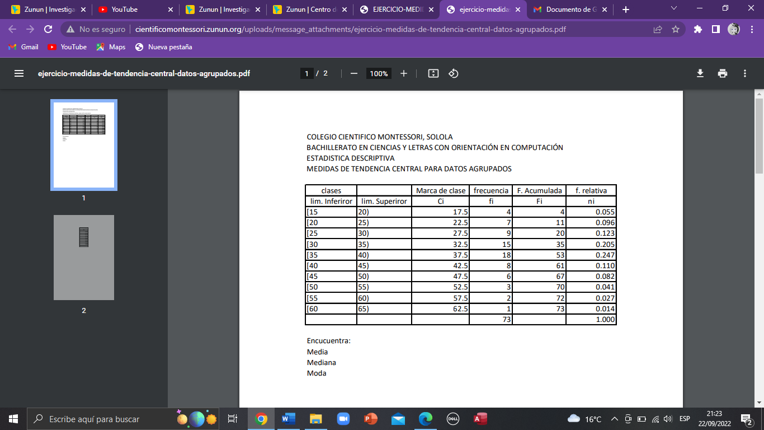**MEDIDAS DE TENDENCIA CENTRAL PARA DATOS AGRUPADOS**

**Media: 35.582 Formula:**

|  |  |  |
| --- | --- | --- |
| **Marca de clase** | **fi** | **Marca de clase* frecuencia**  **Total** |
| **17.5** | **4** | **70** |
| **22.5** | **7** | **157.5** |
| **27.5** | **9** | **247.5** |
| **32.5** | **15** | **487.5** |
| **37.5** | **18** | **675** |
| **42.5** | **8** | **340** |
| **47.5** | **6** | **285** |
| **52.5** | **3** | **157.5** |
| **57.5** | **2** | **115.5** |
| **62.5** | **1** | **62.5** |
|  |  | **2597.5** |

|  |  |
| --- | --- |
| **2597.5/73** | **35.582** |

**Mediana = 35.416**

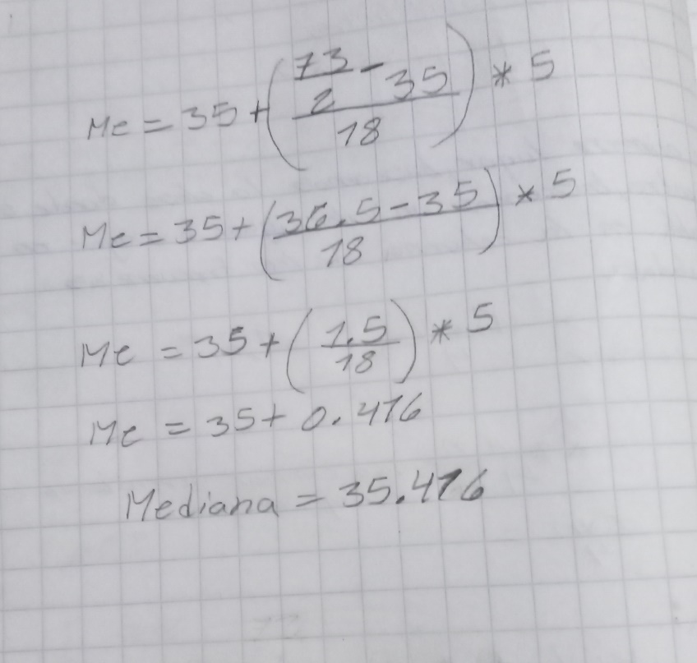

**Moda: 36.153**

