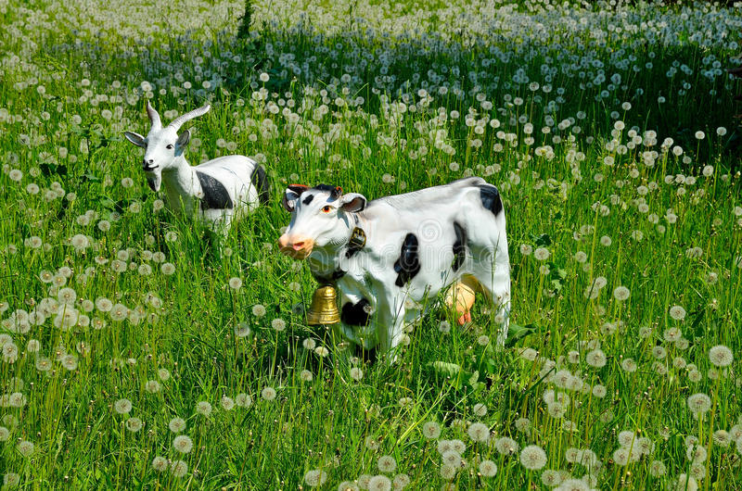THE GOAT AND THE COW

Once open a time there was a goat that lived behind a mountain one day she forgot the way so she got lost.

HELLO HELLO HELLO I need your help please she said to a cow the cow said to the goat great what do you need? The goat said I need to get out of here and return to my house.

The cow helped the goat to return to its house and they lived happy for many years.