Colegio científico montesori, solola

Marializ Inocencia García Say

Eliezer López

Ingles

Tema:

Performance 2 del bloque 2

Tercero básico

Clave: 10

23 de abril de 2021



scenography scenography

scenography scenography

scenography scenography

scenography scenography

scenography scenography

La escenografía es creativa.

Escenografia- scenography

* Alejandra
* Dog Max (perro)
* Mother (madre)
* Boyfriend(Novio)
* Officer (Oficial)

Personajes-Characters

Alejandra va a una gran fiesta la cual le dice a su madre que cuide su perro que para ella es algo que significa todo, la madre le dice que, si lo va a cuidar, entonces Alejandra va con su novio a la fiesta se divierten, minutos después Alejandra vuelve a la casa y le pregunta a su madre donde esta el perro y ella le dice que no lo encuentra porque dejo la puerta abierta y asegura que se abra salido, Alejandra y la madre salen a buscarlo pero no lo encuentran así que vuelven, en eso llega el novio y la fue a ver y decirle que no se preocupe luego se va, después llega un oficial con el perro y le pregunta si es de ella y dice que si y le agradece.

Resumen-resume



**Where is my dog?- ¿Dónde está mi perro?**

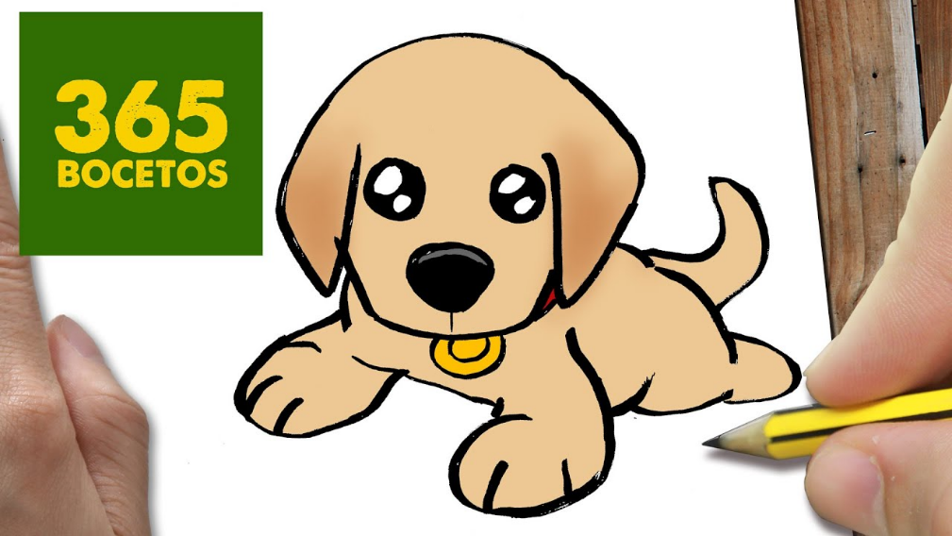

**A common day**

**Alejandra:** Mother, i will go to a great party!

**his mother**: okay

**Alejandra:** i leave you my dog Max; take care of him, means everything to me

**His mother:** Means every thing to you?, Okay do not worry

**Alejandra:** Yes, thank you mother I love you

**ten minutes later Alejandra goes to the party**

**Alejandra:** Goodbye, Mother, take care of my dog Max

**His mother**: Goodbye

**Alejandra is walking with her boyfriend to the party**

**Boyfriend:** Alejandra I feel that the party is going to be a boring party

**Alejandra:** no, it's going to be a great party

**Boyfriend:** If you say it

**five minutes later go to the party and they have fun**

**Alejandra:** tells the boyfriend, we're going home

**Boyfriend:** come on I'll leave you

**the boyfriend leaves her at the entrance and leaves**

**Alejandra:** I'm back mother and my dog Max?

**His mother:** I don't know, it doesn't appear. I left the door open, it sure came out!

**Alejandra:** No!

**His mother:** excuse me, it was a mistake.

**Alejandra:** Mother come on let's find it

**they are going to look for it**

**Alejandra:** Max!

**His mother:** Max!

**an hour later they return home because they did not find him.**

**Where is my dog?-**

**¿Dónde está mi perro?**

**Boyfriend arrives at Alejandra house and says: I heard you lost your dog and I came to see you**.

**Alejandra:** if he got lost and I don't know where he is

**Boyfriend:** soon you find it

**Alejandra:** I'm afraid that something will happen to him

**Boyfriend:** I know that he will return

**Alejandra:** I'll go find it again

**Boyfriend:** stop trying it.

**Alejandra:** I can't, it worries me a lot

**Boyfriend:** Calm down baby

**Alejandra:** Okay, I will try it

**Boyfriend:** Well I have to go, I don't want to leave you alone

**Alejandra:** Okay, never mind, I'll calm down

**Boyfriend:** I love you very much, bye

**Alejandra:** me too, bye

**The boyfriend is leaving**

**Alejandra:** Mother what will I do without my dog

**Mother:** Everything is my fault

**Alejandra:** No mother, it's not your fault, it was an accident

**that's where they knock on the door**

**Alejandra:** Who will it be?

**he was an officer**

**Alejandra:** what's wrong officer?

**Officer:** I found a dog near here is yours?

**Alejandra:** if it's mine, thank you officer

**Officer:** no problem

**The end**