Colegio científico Montessori, Sololá

Marializ Inocencia García Say

Eliezer López

Ingles

Tema:

PERFORMANCE 5 BLOQUE 2

TERCERO BÁSICO

CLAVE: 10

14 DE MAYO DE 2021

La escenografía es creativa.

The scenography is creative

ESCENOGRAFÍA - SCENOGRAPHY

* María (hija)
* Alexandra (madre)
* Rosa (secuestradora)
* Melany (señorita que vende)

PERSONAJES - CHARACTERS

RESUMEN - RESUME

RESUMEN - RESUME

Libérame trata sobre una madre e hija que van a pasear la madre tiene que ir al baño y su hija queda sola, en ese transcurso llega otra señorita y le dice que vayan al parque primero se niega, pero luego acepta y van, la señorita la engaña y la lleva a una bodega (la secuestro). La madre la busca y pregunta le dicen en qué dirección se fue y ella va allí. Ella llama a la madre y le dice que, si quiere a su hija que traiga cien mil quetzales, la madre le dice que es mucho, pero ella le dice que si la quiere tiene que pagar y cuelga. La secuestradora sale y le dice que se quede allí, pero la niña aprovecha y sale en eso se encuentra a su madre.

Set me free is about a mother and daughter who are going for a walk, the mother has to go to the bathroom and her daughter is left alone, in that course another lady arrives and tells her to go to the park, first she refuses, but then accepts and they go, the lady he cheats and takes her to a warehouse (kidnapping her). The mother looks for her and asks her tell her in which direction she went and she goes there. She calls the mother and tells her that if she wants her daughter to bring a hundred thousand quetzales, the mother tells her that it is a lot, but she tells her that if she wants her she has to pay and hangs up. The kidnapper comes out and tells her to stay there, but the girl takes advantage and comes out where she finds her mother.

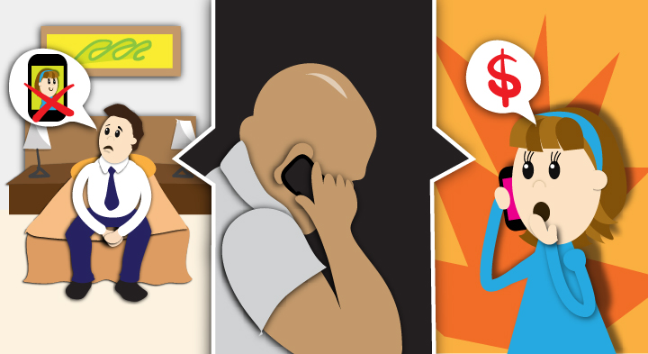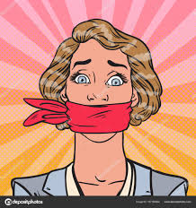

**SET ME FREE – LIBÉRAME**

**One day mother and daughter went for a walk**

**María:** Mother how beautiful are all the stores

**Alexandra:** Although wait for me here don't move I'm going to the bathroom

**María:** Ok mother I wait for you

**Alexandra leaves while Maria goes and watches what is around.**

**Suddenly a girl arrives and says to María**

**Rosa:** Hello my name is Rosa

**María:** Hello?

**Rosa:** What are you doing?

**María:** waiting for my mother he went to the bathroom

**Rosa:** Don’t waste your time

**María:** Wasting my time?

**Rosa:** Yes, let's go to the park for a walk

**María:** my mother said i'll stay here

**Rosa:** It will not be long

**María:** Okay where?

**Rosa:** There, on the left

**Maria and Rosa leave**

**Rosa:** I go to my house to get something and we go to the park

**María:** Okay but quickly

**Rosa takes her to a winery**

**María:** What are we doing here?

**Rosa:** Shut up, you won't get out of here.

**María:** No, set me free

**Rosa:** Shut up now

SET ME FREE –

LIBÉRAME

**Meanwhile her mother goes and looks for her where she left her**

**Alexandra:** Where are you María?, I told you to stay here

**Alexandra he approaches a lady who works there**

**Alexandra:** Hi, sorry, didn't you see a brown haired girl in a black skirt and a pink sweatshirt?

**Melany:** Yes

**Alexandra:** Where?

**Melany:** passed there to the left

**Alexandra:** Thank you!

**Melany:** No problem

**Alexandra look for her, on the streets**

**Alexandra:** María!, María!, María!

**Rosa calls the Maria mother**

**Rosa:**I have your daughter, if you want her, pay one hundred thousand quetzales.

**Alexandra:** Its alot

**Rosa:** If you want it, pay later I'll tell you where you can pick it up and give me the money

**Alexandra:** but...

**Rose hangs up, Rosa tells Maria that she is going shopping and that she can't go out**

**María:** Okay

**Rosa leaves and in that Maria takes advantage and escapes**

**María:** I'm lucky

**Maria and Alexandra meet on the Street.**

**María:** Mother, I was able to escape, Rosa went out to buy and I was able to go out

**Alexandra:** I was too scared I love you I won't leave you alone

**María:** I love you more and I will listen to you

**The end**