Colegio científico Montessori Sololá

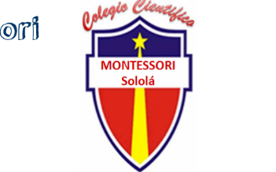

The time i was a scientist

Docente: Eliezer López

Nombre: Franklin Miqueas Cutz Sohom

Curso: Ingles

Grado: 4rto bachillerato

The time i was a scientist

I get up in the morning and get dressed to go to work, my mother yells at me, you're ready and I tell her not yet, I put my lab coat away and give her