

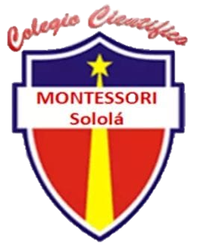

Colegio Científico

“Montessori” Sololá

Performance

Melany Alejandra

Montoya Avila



A couple of months ago my best friend traveled, we thought we would see each other very soon as it was summer vacation.

3 weeks went by and she didn't come back, the holidays were over and she just didn't come back, I asked her parents why, they told me they wouldn't come back, that the place where they lived was full of problems and death threats.

Since that day I learned the truth, his entire family changed numbers and devices.

I haven't heard from her and her family for 2 years, the last thing I said to her was:

- I miss you.

Hace un par de meses mi mejor amigo viajó, pensamos que nos veríamos muy pronto ya que eran vacaciones de verano.

Pasaron 3 semanas y ella no volvió, se acabaron las vacaciones y ella simplemente no volvió, le pregunté a sus padres por qué, me dijeron que no volverían, que el lugar donde vivían estaba lleno de problemas y amenazas de muerte.

Desde ese día que supe la verdad, toda su familia cambió de números y dispositivos.

No he sabido nada de ella y su familia durante 2 años, lo último que le dije fue:

- Te extraño.