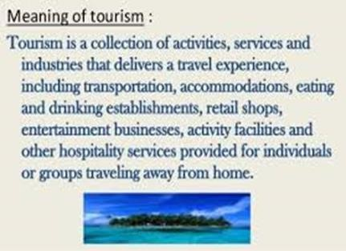

**MINISTERIO DE EDUCACI**

**Ó**

**N**

**Learning Guide for Tourism Students**

**10**

**II TRIMESTRE**

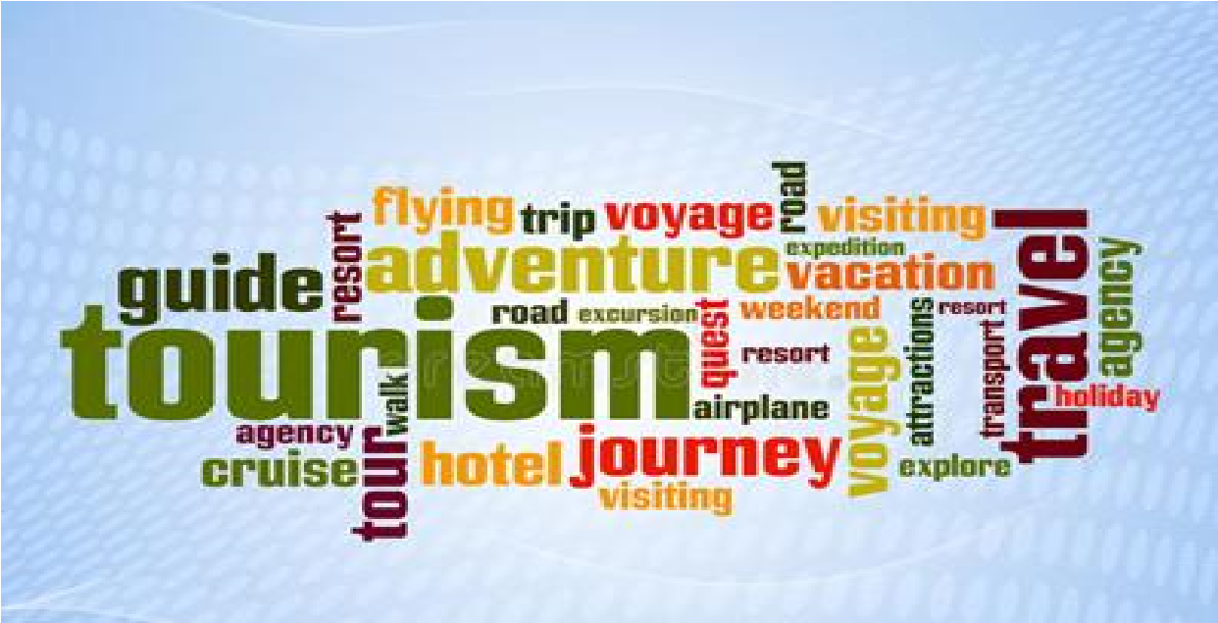

**By Teacher Zoraida López**

**For Students of 10 Tourism**

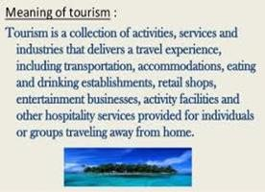

**Gatuncillo Hight School**



**Learning Guide**

# English

**10 A, 10 B, 10 C Tourism II TRIMESTRE**

# Justification

English is important for students of Tourism because it helps to communicate with different kind of guest. This is because English is an international and official language.

This learning guide deals with the use of prepositions in touristic activities, contains vocabulary about geographical aspects in our country and the way to ask and give information about quantity and prices in a town or store. This helps the student of tourism to have notions of how to guide a tourist in a city.

## General objetive

✓ To become aware of the importance of the knowledge of the giving directions in English for the Tourism in his/her country.

## Specific objective

* To differentiate the use of the prepositions (in, on, at and by) in touristic activities.
* To recognize the importance of the knowledge of the geography of Panama to work in the tourism industry. in our country.
* To ask questions related to the quantity using countable and uncountable nouns.
* To identify the way to ask price in a store and giving answers.

# Table of Content

1. **Preposition in and on**

Activity #1

1. **Preposition by and at**

Activity # 2

1. **Geography of Panama**

Activity # 3 Vocabulary

Activity # 4 Reading comprehension

1. **How much/how may: countable and uncountable nouns.**

Activity # 5

1. **How much for asking price**

Activity #6

# Evaluation

**Bibliography**

## I. PREPOSITIONS: on and in

A preposition is a word that links a noun, pronoun, or noun phrase to some other part of the sentence. A preposition is used to show direction, location, or time, or to introduce an object.

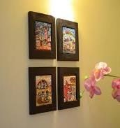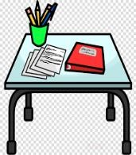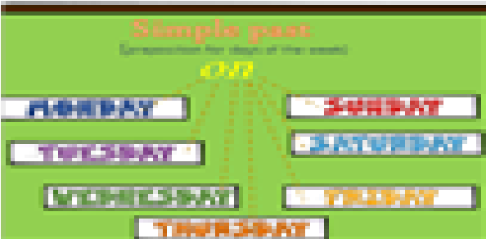

**On**

Used to express a surface of something:

I put the pictures **on** the wall The paper is **on** my desk.

Used to specify days and dates:

The garbage truck comes **on** Wednesdays.

I was born **on** the 14th day of June in 1988.

Used to indicate a device or machine, such as a phone or computer:

He is **on** the phone right now.

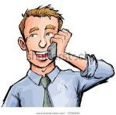

She has been **on** the computer since this morning.

My favorite movie will be **on** TV tonight.

Used to indicate a part of the body:

He kissed me **on** my cheek.

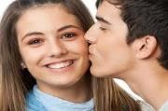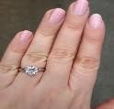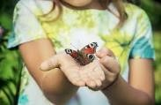

I wear a ring **on** my finger.

She has a butterfly **on** her hand

Used to indicate the state of something:

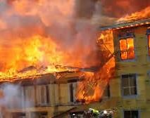

Everything in this store is **on** sale.

The building is **on** fire.

**In**

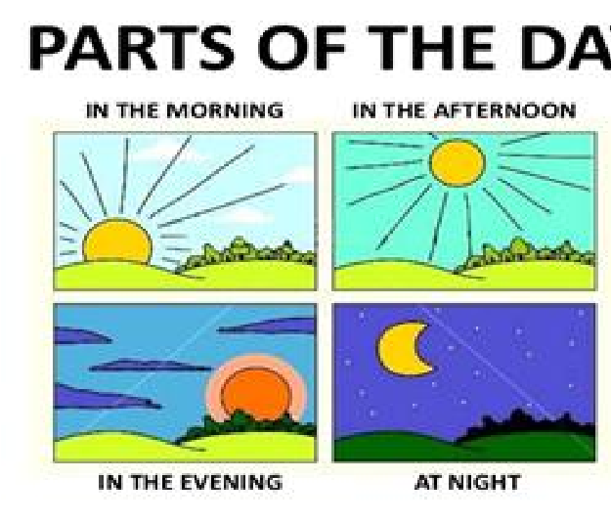

Used for unspecific times during a day:

She always reads newspapers **in the morning.**

We arrive **in the afternoon**.

I travel to Jamaica **in the evening**

Used for the seasons:

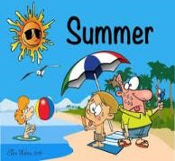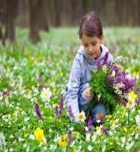

Used for the seasons:

**In the spring,** there are a lot of flowers in the gardens.

The tour to the beach will be **in the summer**.

The boy wears scarf **in the winter.**

They collect the leaves **in the fall.**

Used for months:

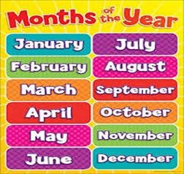

The new semester will start **in June.**

Christmas is celebrated in **December.**

Used for years:

Panama Canal was inaugurated **in 1915.**

They graduated as a tour guide **in 2016.**

Used to indicate a location or place:

I am currently staying

**in**

a hotel.

We live in Paris

.

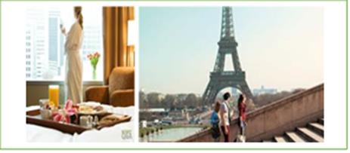

I study in Gatuncillo.

Used to indicate a shape, color, or size:

This painting is mostly **in** blue.

The lady wears **in yellow** The boys come **in white**

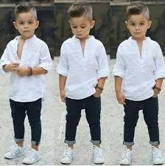

This jacket comes

**in**

four different sizes.

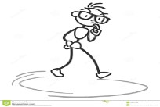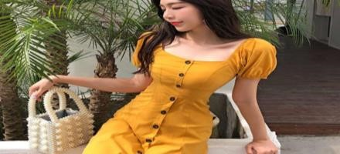

The student walk **in** a circle.

### ACTIVITY # 1

**Student´s name: _________________________ Level: _______________**

**Complete the sentences using the prepositions in or on.**

**Examples:**

The travel arrives **_*in*** the morning.I was ***on*** the phone.

1. Many women like to wear _______ red.
2. The independence of Panama from Spain was ____1821
3. Many items in the store are _____ sale.
4. In Panama, the children day is celebrated _____ July
5. He puts the keys ______ the desk.
6. Tourists have the brochures ____ their hands.
7. The receptionist is _________ the computer.
8. Panamanian students have vacations _____the summer.
9. The new secretary lives _______Colon.
10. I go to the school ______ the afternoon.

## II. Preposition At and By

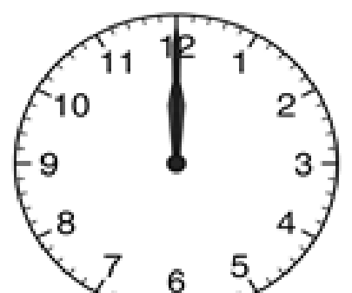

**At**

Used to point out hours and night

I will meet you **at** 12 o´clock

The bus will stop here **at** 5:45 p.m.

The tourists arrive **at** night.

Used to indicate an email address:

Please email me **at turismoabc@gmail.com**

**By**

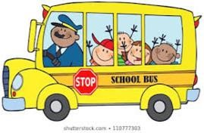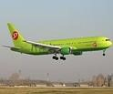

Used to indicate means of transportation:

We go to the school **by** scholar bus

Tourists travel to France **by** airplane.

Used to indicate authorial:

The brochure was designed **by** Rose.

The reservations were made **by** me.

The book was written by Edgar Alan Poe.

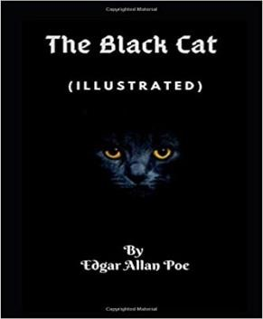

### ACTIVITY # 2

**Student´s name: _________________________ Level: _______________**

**Complete the sentences using the prepositions at or by.**

**Examples:**

We left home ___***at____***six o´clock.

The Panama Canal was built ____***by____*** United Stated of American.

1. We left home ________ six o´clock.
2. Send me the report ________ irenecruz@gmail.com.
3. They travelled to Mexico ________ airplane.
4. The Quijote was written ___________ Miguel de Cervantes.
5. The first Panamanian flag was sewn ___________ Maria Ossa de Amador
6. The flight land off ________ 2: p.m.
7. I´ll go to visit the Canal of Panama _______ bus.
8. They study _______ night.
9. The Eiffel Tower was designed and built ________ Gustave Eiffel.
10. The tourists travel to Darien _____ boats.

**III: Geography of Panama.**

**Activity # 3**

**Vocabulary:**

**Look up the following words in the dictionary and define them.**

Example: **Gulf:** a gulf is a portion of the ocean that penetrates the land.

1. **Border ____________________**
2. **Climate _____________________**
3. **Desert ____________________**
4. **Eagle ____________________**
5. **Island ___________________**
6. **Lake ____________________**
7. **Orchid ______________________**
8. **Port ____________________**
9. **River ____________________**
10. **Volcano _____________________**

**Reading Comprehension**

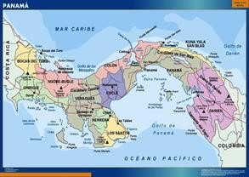

Panama is a country located in Central America. Their borders are the

Caribbean Sea at the North and the Pacific Ocean at the South; at the East, Colombia and at the West, Costa Rica. Panama forms the narrow and low Isthmus of Panama.

Panamá is divided into 10 provinces: Bocas del Toro, Cocle, Colón, Chiriqui, Darien, Herrera, Los Santos, Panama, Panamá Oeste y Veraguas and several indigenous comarcas such as Guna Yala and Ngobe- Bugle. The provinces are divided into districts.

Panama has a tropical climate with two seasons; rainy season and dry season. The dry season, Panama´s ¨summer, ¨ lasts from December to April while the rainy season (winter) takes place the remaining portion of the year. Summer entails hot sunny days with mostly blue skies, cool nighttime breezes, and starlit skies. Winter mostly means warm days with hazy skies and short, refreshing bursts of afternoon downpours and/or thunderstorms; and conditions vary according to the region. The Azuero Peninsula, for example, is a large peninsula in Southern Panama that has a unique less humid climate with little rainfall, nicknamed Arco Seco, ¨Dry Arch.¨ It features a dry rainforest on the West Coast and a long dry season. A man-made desert lies in the Northeastern portion of the peninsula, called the Sarigua desert, formed from the constant grazing and cultivation of the land for thousands of years.

Panama's tropical environment supports an abundance of plants. Home to animal and flower species of a wide variety, Panama flora and fauna is known for its diversity. Panama is a land of thick rain forests and great wildlife. Flora in

Panama comprises about nine thousand species of flowering plants. Among these varieties, Holy Ghost Orchid is the national flower.

Flora and fauna in Panama attract people from all over the world. The mammals living in Panama are anteater, coati, armadillo, bat, peccary, deer, opossum, tapir, raccoon, and many varieties of monkeys. The reptiles mainly include the alligators, which are found in plenty along the coasts. The birds and fishes found in Panama migrate from different places. The harpy eagle, largest of the neotropical raptors, the solitary and the crested eagle is the national bird of Panama. La Amistad International Park preserves the Panama flora and fauna and protect them in the best way- Also Panamanians supports the growth of flora and fauna in Panama with forest reservations or the national parks such as Darien National Park, Chagres National Park, Metropolitan National Park.

The most famous lake of all is Lake Gatun, an artificial lake that played and still plays a crucial role in the Panama Canal. Thanks to a genius plan to dam the Chagres River and create Lake Gatun, the Americans were able to control the untamable river and complete the Panama Canal. Today, Lake Gatun serves as a passageway for the large vessels crossing the isthmus.

Almost 500 rivers flow across the length of Panama, with Chagres River and Chepo River being the two most well-known, and the Chucunaque River being the longest situated in Darien. Sitting in an estuary in Panama, where a freshwater river or stream meets the ocean, is definitely a unique experience of nature that one can easily enjoy.

The major port on the Pacific coastline is Balboa. The principal islands are those of the Pearls Archipelago: Contadora and The King in the middle of the Gulf of Panama. Also, there is a decorative island of Taboga, a tourist attraction that can be seen from Panama City.The largest island in Panama is Coiba in the Chiriqui Gulf.

Panama's highest point is Baru Volcano at 3,475 meters (11,401 ft) in the province of Chiriqui. Baru Volcano last erupted in 1550 and is the apex of a highland that includes Panama's richest soil.

### Activity # 4

**After reading the article: Geography of Panama, fill the following blanks.**

1. The borders of Panama are: North__el mar caribe

South__el oceano pacifico

East__colombia

West ___costa rica

1. Write two provinces in Panama: ___dividido en dos distritos

_________________

1. The National flower of Panama is the paristeria _elata
2. It is the national bird of Panama Of __aguila __arpia
3. The highest point in Panama is ____volcan___baru__
4. The Largest Island in Panama is __la del rey___________

## III. How much/ how many

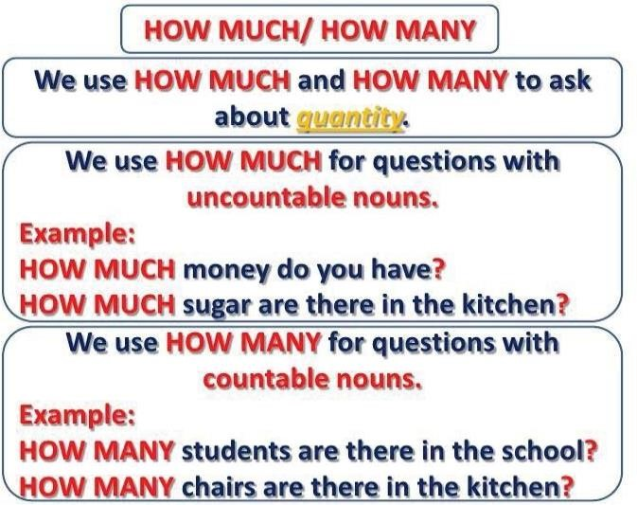

**Examples**

**Countable nouns**

**Bank library hotel**

**school theater students**

**Examples:**

**uncountable nouns**

**water traffic pollution**

**crime noise money**

Remember:

How many

uses

are

How much

use

s

is

**QUANTITY EXPRESSIONS**

**Uncountable nouns Countable nouns**

**many**

**a lot**

**many**

**only a little**

**a couple**

**not any**

**not any**

**ACTIVITY # 5**

**Student´s name: _________________________ Level: _______________**

**I. Write questions using “*How much…? or how many* …?” Then look the picture and answers to the questions. Use the expressions of quantity in the box.**

(Escriba: How many cuando es un countable noun y How much cuando es un uncountable nouns. En la respuesta vea la imagen y describa la cantidad que ve de acuerdo a las quantity expressions dadas en el cuadro)

### *a lot a couple many only a little not any*

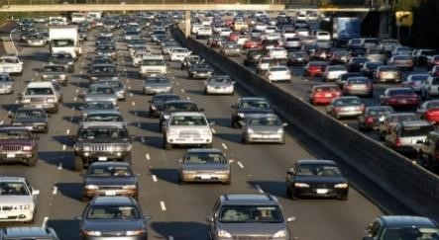 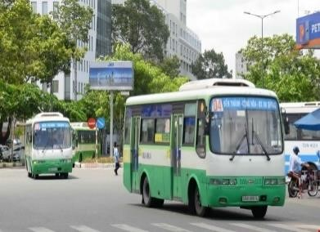

1. *How much* crime is there? 2. *How many* buses are there? There is *a lot* There are *a couple.*

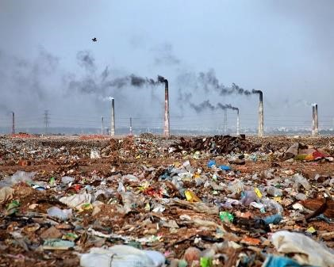 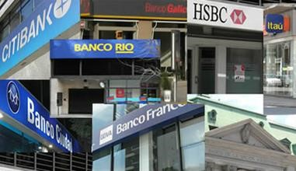

3._____________- pollution is there? 4. ________________ banks are there?

There is ____a lot________ There are ___only__a little

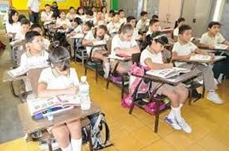 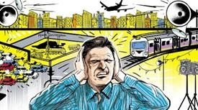

5.______________ students are there? 6. ________________ noise is there?

There are ____many__________ There is __Not________________.

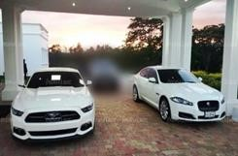

7. __________________ cars are there?

There are __a couple_________________

***IV. HOW MUCH ...? Asking for price.***

**How much can also be used when we want to know the PRICE of something. In this case, we can use How much with countable nouns**

**(both singular and plural nouns).** (**how much** se usa para preguntar precios. Puede ser con plural o singular); conuntable or uncountable nouns)

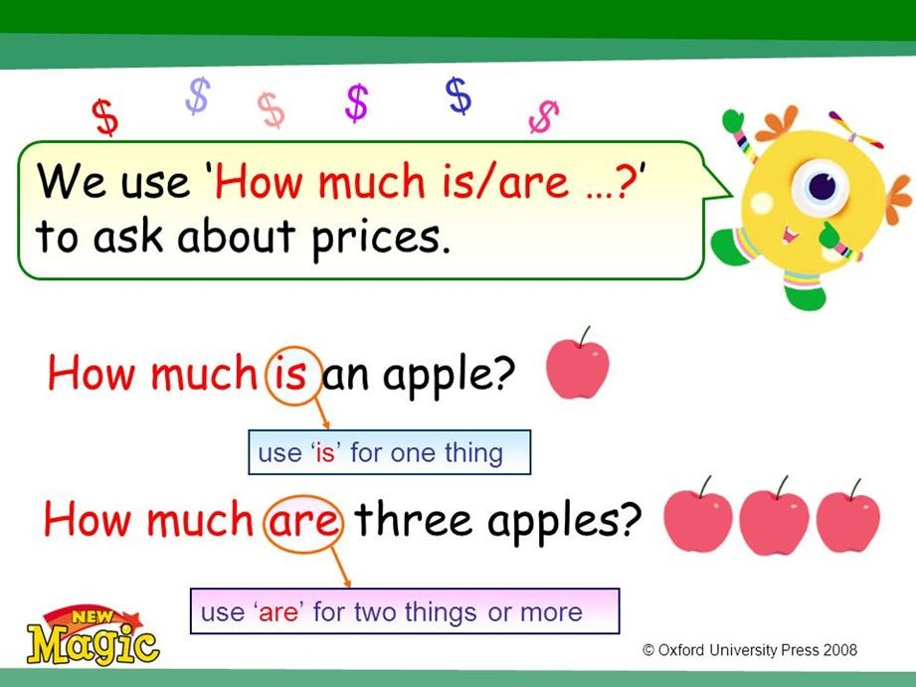

**Activity # 6**

**I. Complete the conversations with how much is / are…? Answer giving the price. Use the items of the picture.**

**Student´s name__________________ Level: __________**

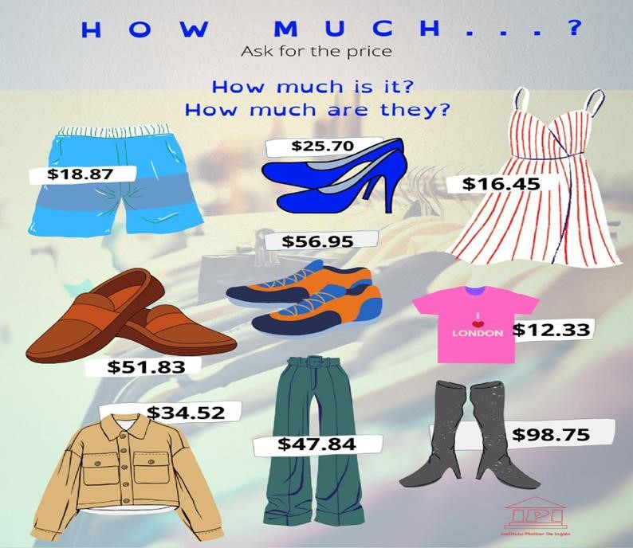

Examples.

1. How much are the lady shoes?

They are 25.70 dollars.

(cuando el producto a comprar es plural se usa **are** y en la respuesta **they are**)

1. How much is the dress?

It is 16.45 dollars.

(cuando el producto a comprar es singular se usa **is** y en la respuesta **it is**)

1. ____________________ the jacket?

________________________.

1. _______________________ the boots?

_______________________

1. _______________________ the tennis?

________________________

1. _______________________ the short pants.

_____________________________.

1. _________________________ brown shoes?

__________________________-

**Evaluation.**

Activity # 1 ND 10 points ________________

Activity # 2 NA 10 points ________________

Activity # 3 NA 10 points ________________

Activity # 4 NA 10 points ________________

Activity # 5 ND 10 points _______________

Activity # 6 ND 10 points _______________

.

Fecha de entrega de la guía desarrollada al correo 12 de agosto.

Consultas o dudas de los temas chatear al 68421581. Estamos para explicarles sus dudas.



**Bibliography:**

**https://learningenglish.voanews.com/a/prepositions-time-place-everydaygrammar-in-on-at/2732061.html https://madridingles.net/how-much-how-many-contable-e-incontable/ https://open.books4languages.com/english-a1-grammar-es/chapter/howmany-and-how-much/**

**HENSION**

**READING COMPREHENSION**

**R** **READING COMPREHENSION READING COMPREHENSION**

**EADING COMPREHENSION**