

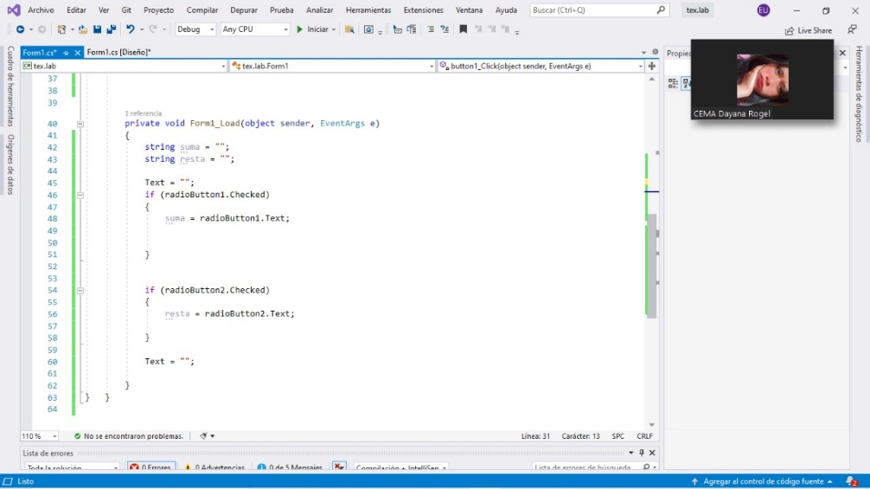

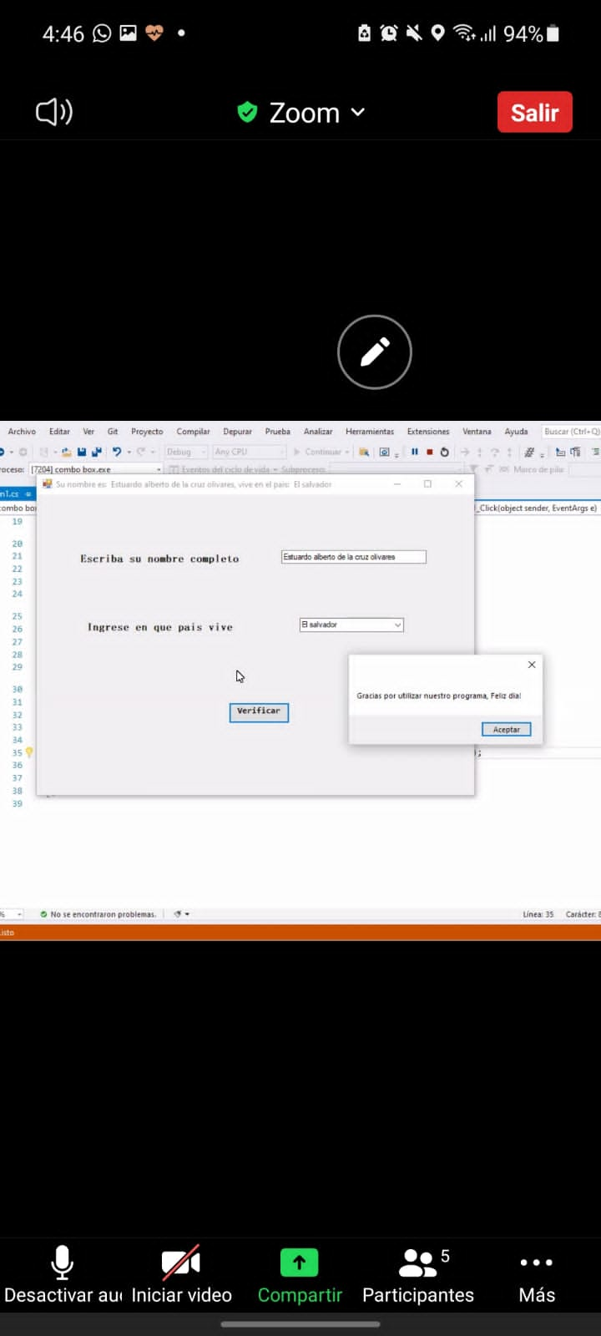







using System;  
using System.Collections.Generic;  
using System.ComponentModel;  
using System.Data;  
using System.Drawing;  
using System.Linq;  
using System.Text;  
using System.Threading.Tasks;  
using System.Windows.Forms;  
  
namespace tex.lab  
{  
public partial class Form1 : Form  
{  
public Form1()  
{  
InitializeComponent();  
}  
  
private void button1_Click(object sender, EventArgs e)  
{  
Text = "";  
int num1 = int.Parse(textBox1.Text);  
int num2 = int.Parse(textBox2.Text);  
  
int suma = num1 + num2;  
  
Text = suma.ToString();  
  
int resta = num1 - num2;  
  
Text = resta.ToString();  
  
  
  
}  
  
  
  
private void Form1_Load(object sender, EventArgs e)  
{  
string suma = "";  
string resta = "";  
  
Text = "";  
if (radioButton1.Checked)  
{  
suma = radioButton1.Text;  
  
  
}  
  
  
if (radioButton2.Checked)  
{  
resta = radioButton2.Text;  
  
}  
  
Text = "";  
  
}  
} }

