Welcome to Kingsoft Office

Dear user:
Thank you for using Kingsoft Office for Android. With its help, your life will be both easier and more efficient.
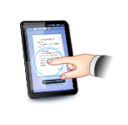
With the ability to edit documents on the go, you’ll enjoy true office mobility.
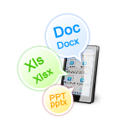
With Kingsoft Office, you’re able to view and edit documents locally or using cloud storage. The edit function includes text editing, format processing, tables, pictures and more. It includes an easy to use touch screen that grants users the ability to work anywhere in the office！
Compatible with multiple formats and easily to manage files.

Kingsoft Office supports the latest Microsoft & Kingsoft Office formats (DOC, DOCX, XLS, XLSX, PPT, PPTX & TXT) whilst the built-in file manager makes managing files easy.
Closely integrated with Email, you can send file attachments easily.

You’re allowed to send documents by Email, including the ability to edit, send, and save attachments.
Access to cloud storage allows you to share documents anywhere, at anytime.
With Kingsoft Office, you’re able to view, edit, and save files stored using cloud storage. This makes it easier to sync, save, and share files..
Your feedback is highly valued and will help us to continually improve Kingsoft Office. We’ll keep working on the App and will release more new features in the future to make Kingsoft Office as powerful as other Office applications in PC.

Enjoy!
Yours sincerely,
Kingsoft Office Team

